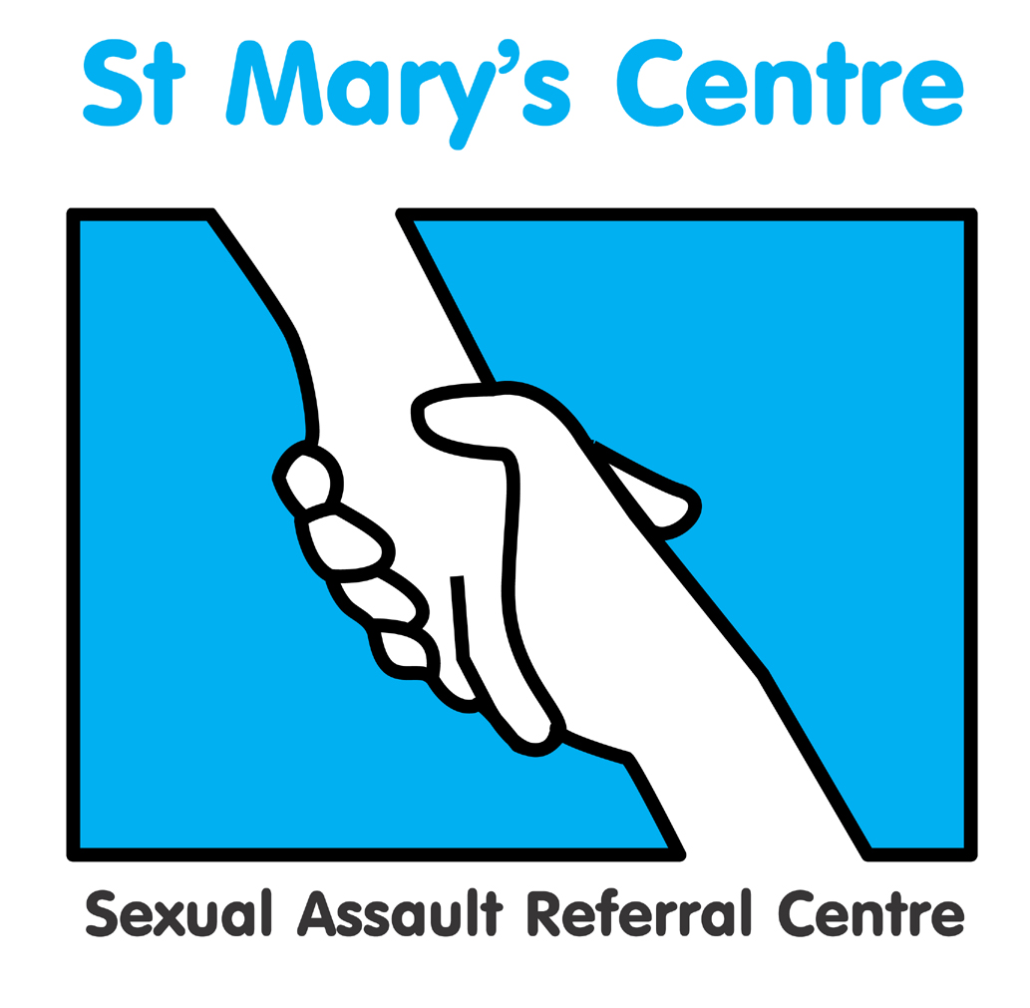

Saint Mary’s Centre 22nd Annual Conference 2025
Tuesday April 29th and Wednesday April 30th 2025
The Midland Hotel, Manchester

Building Bridges: Collaborative Approaches to Addressing Sexual Violence

BOOKING FORM

PLEASE do not send payment with your booking form

Title |  | Name |  | Position
Organisation
Email

Signature |  |  |  | Date
Is there any way Saint Mary’s Centre could
support your attendance at the conference?
Please indicate any special dietary requirements:

Please ensure all three pages of this document have been completed before it is returned to josh.edgar@mft.nhs.uk

 | Day One (29th April) | Day Two (30th April) | Full Conference  (Both days special rate)
Charities, voluntary and Third Sector | £270 | £270 | £360
UK SARCs | £270 | £270 | £360
All other agencies | £300 | £300 | £400

Discounted rates may be available for group bookings, please contact us directly to discuss this.

How did you hear about this event?

What do you hope to achieve/obtain by attending?

PAYMENT DETAILS

Payment will be expected upon receipt of an invoice issued by Saint Mary’s SARC based on the information provided below.

If payment is being made by your organisation, please can you check whether you need to supply us with any additional information such as a Purchase Order numbers and if so, please include this in the space provided below.

Upon receipt of the invoice, you will be able to pay using a variety of methods including credit card, BACS or cheque.

Please do not include cheques when submitting this form.

PLEASE COMPLETE DETAILS BELOW ACCURATELY FOR INVOICING PURPOSES
Invoice details |  | Invoice for total £ (Sterling only) to be sent to the person below
Person or organisation to be invoiced |  |  | Tel
Purchase order number
(Please provide with the booking form)
Full address the invoice needs to be sent to
Please fill this in, it cannot be left blank

Email address

Please return the completed booking form and any purchase orders to:
josh.edgar@mft.nhs.uk

Cancellations must be received in writing before January 31st 2025. Fees will be returned minus a 10% administration charge. No refunds will be made after that date. Programme subject to change.

