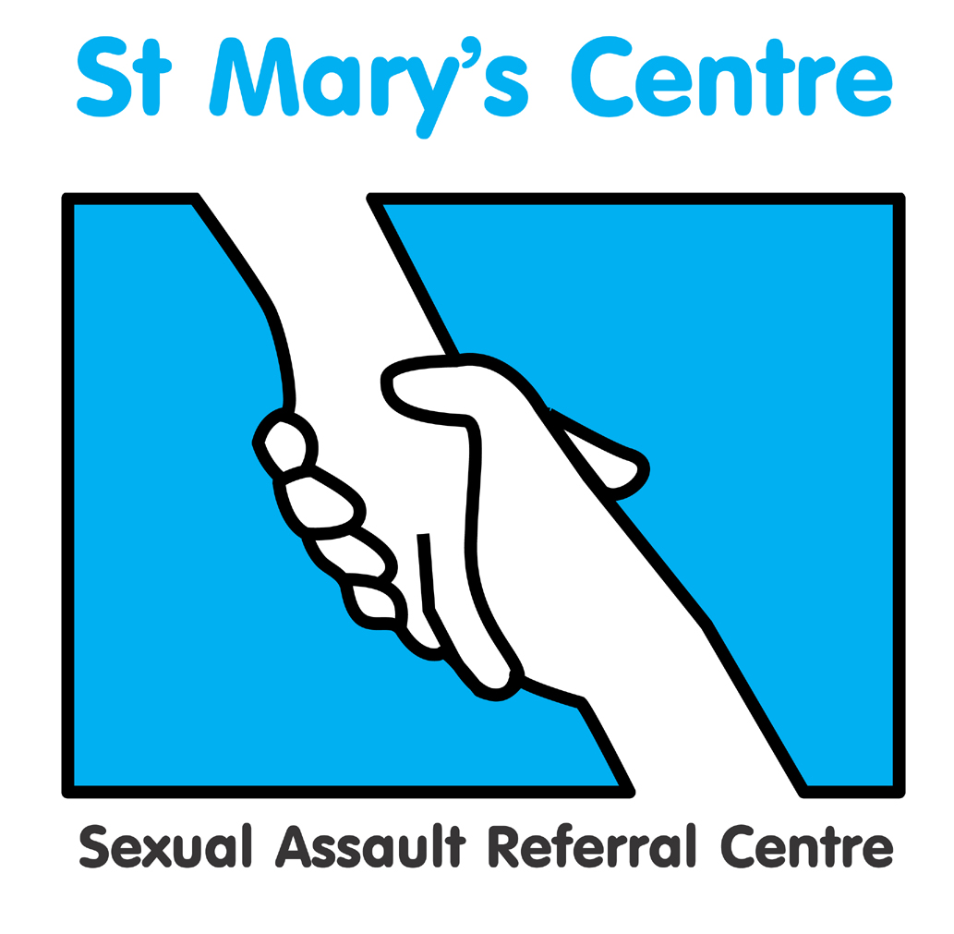

Saint Mary’s Centre 20th Annual Conference 2023
Tuesday April 25th and Wednesday April 26th 2023

The Midland Hotel, Manchester

Protecting Children in the Digital Age

BOOKING FORM

PLEASE do not send payment with your booking form

Title |  | Name |  | Position
Organisation
Email

Signature |  |  |  | Date
Is there any way Saint Mary’s Centre could
support your attendance at the conference?
Please indicate any special dietary requirements:

Please ensure all three pages of this document have been completed before it is returned to stmarys.sarc@mft.nhs.uk

 | Both Days | Day One (25th April) | Day Two (26th April) | Early Bird Pass (book before 05/11/22)
Charities, voluntary and Third Sector | £360 | £270 | £270 |  £280
UK SARCs | £360 | £270 | £270 |  £280
All other agencies | £400 | £300 | £300 |  £340

Discounted rates may be available for group bookings, please contact us directly to discuss this.

We invite all our guests to join us for a three course evening meal which will be taking place 25th April from 19:00. The meal is held at the Midland Hotel and is priced at £52.

Please tick this box if you will be joining us. 

How did you hear about this event?

What do you hope to achieve/obtain by attending?

PAYMENT DETAILS

Payment will be expected upon receipt of an invoice issued by Saint Mary’s SARC based on the information provided below.

If payment is being made by your organisation, please can you check whether you need to supply us with any additional information such as a Purchase Order numbers and if so, please include this in the space provided below.

Upon receipt of the invoice, you will be able to pay using a variety of methods including credit card, BACS or cheque.

Please do not include cheques when submitting this form.

PLEASE COMPLETE DETAILS BELOW ACCURATELY FOR INVOICING PURPOSES
Invoice details |  | Invoice for total £ (Sterling only) to be sent to the person below
Person or organisation to be invoiced |  |  | Tel
Purchase order number
(Please provide with the booking form)
Full address the invoice needs to be sent to
Please fill this in, it cannot be left blank

Email address

Please return the completed booking form and any purchase orders to:
stmarys.sarc@mft.nhs.uk

Cancellations must be received in writing before January 31st 2023. Fees will be returned minus a 10% administration charge. No refunds will be made after that date. Programme subject to change.

