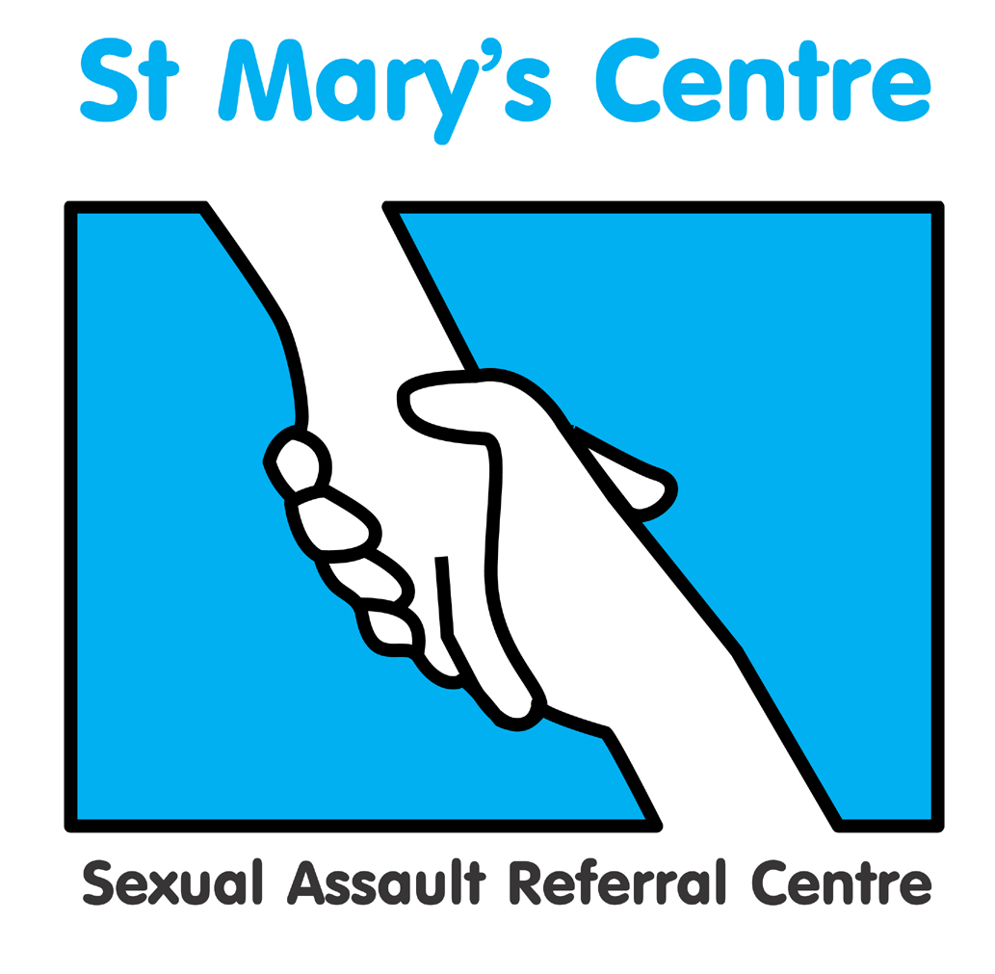

Practice of

Forensic and Medical Examination
for Rape and Sexual Assault

Course Guide Unit Two

5th, 6th & 7th September 2023

&

10th, 11th & 12th October 2023

Course Unit Leader: Dr Cath White

.
Contents

Section | Topic | Page
1 | Course Unit Leader Contact Details | 3
2 | Introduction to the Course Unit | 3
3 | Course Unit Aims and Outcomes | 4
4 | Teaching/Learning hours and Methods for the Course Unit | 5
5 | Student Support During the Course Unit | 5
6 | Assessment | 6
7 | Evaluation | 7
8 | Core Learning Materials | 7

1. Course Unit Leader Contact Details

Name | Location | Telephone no.s | E-mail
Dr Cath White | Saint Mary’s Centre  Mobile | 0161 276 6515  07887 730033 | catherine.white2@nhs.net

2. Introduction to the Course Unit

Welcome to Unit Two of the St. Mary’s Course: Practice of Forensic and Medical Examination for Rape and Sexual Assault.

During this course unit you will develop further the forensic medical skills learnt in Unit One, Principles of Forensic and Medical Examination for Rape and Sexual Assault, and explore further the legal framework, support services and social context underlying the work of the forensic clinician.

This course is delivered by practitioners who are expert in their fields.

Content

- Mental capacity law
- Signs, symptoms and management of drug misuse
- Drug-facilitated sexual assault
- Mental health assessment
- Vicarious Trauma
- Genital anatomy and age
- Child protection information sharing
- Paediatric forensic medical examination theory
- Forensic medical examination practical skills
- Forensic medical examinations – setting and infrastructure
- Homelessness and health
- Photodocumentation of injuries
- STI screening and treatment pathways
- Recording findings
- Documentation – practical session
- Statement writing preparation and review
- Sexual violence in the context of domestic abuse
- Elder abuse and self-referrals
- Disclosure of notes
- Court room skills
- Psychological effects of sexual violence
- Vulnerable adults and adolescents
- Role of the witness
- A Judge’s view
- Child Sexual Exploitation
- Male Rape
- Emergency contraception
- Post Exposure Prophylaxis
- Vicarious trauma
- SARC concepts of integrated multi-disciplinary approach
- Learning disability
- Female Genital Mutilation
- PACE & management of suspects in custody

3. Course Unit Aims and Outcomes

  - Aims

This course unit aims to enable qualified healthcare professionals (who have completed the course unit ‘Principles of Forensic and Medical Examination for Rape and Sexual Assault’ or are able to demonstrate equivalent knowledge and experience) to further enhance their knowledge and understanding of legal, ethical and policy frameworks and processes, and specific procedures relevant to the practice of forensic and medical examination for rape and sexual assault, and apply these across a range of patient groups and contexts.

It is specifically aimed at doctors and nurses (and other qualified health professionals) who wish to extend their knowledge and skills, in terms of breadth and depth, in order to practice as forensic clinicians.

  - Outcomes

3.2.1 Knowledge and Understanding

- Demonstrate in-depth and critical understanding of the Sexual Offences Act 2003 and the investigation and prosecution of rape and sexual assault.
- Reflect on and critically evaluate the nature and processes for forensic examination and related forensic, medical and ethical issues.
- Critically evaluate the evidence base relevant to forensic examination in order to put any examination findings into context.
- Demonstrate an in-depth and critical understanding of the psychological sequelae to rape and sexual assault.
- Demonstrate a sound understanding of factors related to the preparation of prosecution and defence cases in the context of the criminal justice process.
- Demonstrate a clear understanding the context of sexual violence in health presentations and the holistic needs of clients

    - Intellectual Skills

- Systematically identify and critically appraise, information from a variety of sources in order to develop a coherent analysis of issues relating to the practice of forensic and medical examination.
- Utilise and apply relevant knowledge and understanding to construct sound arguments based on critical analysis and evaluation.
- Critically analyse relevant evidence and testimony of others for accuracy and effectiveness.

3.2.3 Transferable Skills and Personal Qualities

- Prepare and write comprehensive and clear reports/statements.
- Demonstrate effective written and verbal communication skills in a range of contexts, with other professions, the public, juries, and under cross-examination.

4. Teaching/Learning Hours and Methods for the Course Unit

Activity | Hours allocated
Taught sessions | 40
Tutorial time | 2
Self-directed study | 158
Total hours | 200

Tutorial time may be one-to-one, group, face-to-face, virtual, telephone or email. Lectures will be mainly didactic, with audio-visual elements, interactive question and answer sessions, and use of anatomical models. Where possible they will be in person, but may need to be virtual dependent upon restrictions related to the pandemic.

  - Independent study

As you will see from the hours above, there is a considerable amount of time allocated to independent study. It is important that you organise yourself to undertake these additional hours as they are as important to your learning as direct teaching. This equates to approximately 14 hours per week from the start of the course to the deadline for the assessed essay. This time includes that spent observing forensic medical examinations and visiting relevant organisations, as well as preparation for the essay.

5. Student Support during the Course Unit

  - Academic tutors

Each student will be allocated an academic tutor from the course teaching team who is available for academic support and advice during the unit of study. The Course Leader is also one of the academic tutors.

The best way to arrange an appointment is by contacting your tutor in person or via telephone or e-mail.

Please remember that all teaching team members are also engaged in many other activities and therefore may not be available to see you immediately. It is preferable to contact them in advance to arrange a mutually agreeable appointment.

6. Assessment

Assessment activity | Length required | Weighting within unit
Essay  In which students are required to critically analyse and evaluate current research and literature relating to the significance of genital injuries in post pubertal complainants of rape and sexual assault, identifying implications for the practice of forensic and medical examination for rape and sexual assault.  Candidates will be marked on inclusion of the key topics, literature, studies and cases that should be mentioned and the school general assessment criteria for level 3 work.  Criteria for success are:  - Ability to identify and demonstrate in-depth knowledge and understanding of relevant literature and research  - Show evidence of critical analysis and evaluation of the chosen topic  - Ability to integrate theory and practice.  A minimum mark of 40% must be achieved for successful completion. This assignment is designed to meet learning outcomes 1 – 8 and 10. | 5,000 words (+/- 10%) | 100%

Students are also required to:

- Attend a minimum of 80% of taught sessions

  - Submission date for essay

- The essay must be received in electronic form at the St Mary’s Centre by 12 noon on Friday November 17th 2023. Please send these to josh.edgar@mft.nhs.uk

- Please provide essays in word format not PDF.

- You are strongly advised to retain a copy of written assignments.

- Please note we use Harvard style for all referencing. If you don’t know what this is then please speak with your tutor or the course administrator.

- Please note that failure to submit by the deadline will result in a mark of zero. If in exceptional cases you need an extension please contact the course administrator, Josh Edgar, for an extension form.

- Please make your submission for an extension in good time. Extensions of more than two weeks will have to be agreed by Dr Catherine White. Please note extensions will result in delays in essay marking and therefore obtaining of essay results.

  - Draft work and guidance

Academic tutors will be available to provide guidance and advice on the essay as you are working on it. They will view one essay plan/outline with notes of up to 500 words providing it is received up to two weeks before the essay submission date. Tutors will not review full drafts.

6. Evaluation

Evaluation of all elements of course units is essential in order to reflect on your own learning, provide feedback on the strengths and potential areas for enhancement of the teaching and learning experience. The following methods of evaluation will be utilised:

- Anonymous structured questionnaires (quantitative)

- Group evaluations (qualitative)
This will take place at the end of teaching on the final day of the course

7. Core Learning Materials

1. Audio-Visual Resources

American Forensic Nurses, The Sexual Assault Examination: Essential Forensic Examination and Instructional Reference Guide (DVD).

- Internet Resources

American Journal of Forensic Medicine and Pathology
http://www.amjforensicmedicine.com

British Medical Association www.bma.org.uk

Faculty of Forensic and Legal Medicine www.fflm.ac.uk

Forensic Science International http://www.sciencedirect.com/science/journal/03790738

General Medical Council www.gmc-uk

The Home Office www.homeoffice.gov.uk

Journal of Clinical Forensic Medicine http://www.harcourt-international.com/journals/jcfm

Journal of Forensic Nursing http://www.forensicnurse.org

Journal of Forensic Sciences http://www.blackwell-synergy.com/loi/jfo

Journal of Legal Medicine http://www.tandf.co.uk/journals/titles/01947648.asp

St. Mary’s Sexual Assault Referral Centre www.stmaryscentre.org

The United Kingdom Assocation of Forensic Nurses
http://www.ukafn.org/

The National Society for the Prevention of Cruelty to Children
www.nspcc.org.uk

The Office of the Children’s Commissioner in England

http://www.childrenscommissioner.gov.uk/

