Signs and Symptoms of FGM

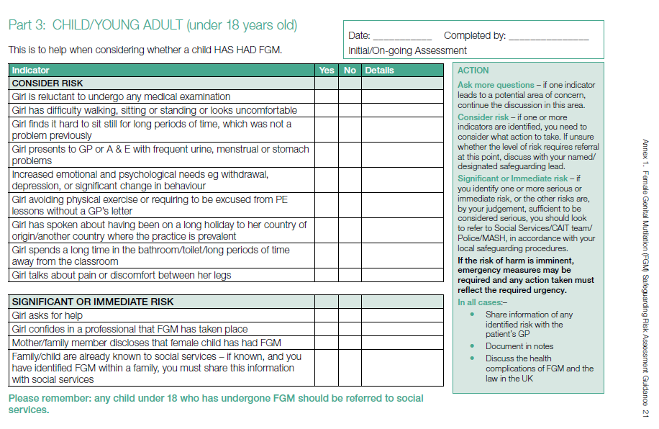

**Strategy discussion**

**Social:**

* What is known of the family?
* What other issues face the child?
* Involve Specialist 3rd Sector agency to aid communication and understanding

**Police:**

* Previous knowledge of family
* Has a criminal offence been thought to have been committed?

**Hold Strategy discussion within 48 hours,**

**Involving: Health, SARC, Police, Education / School,**

**3rd Sector cultural liaison.**

**Health**:

* Is the girl currently suffering any physical or psychological symptoms due to FGM?
* Is she likely to have health problems (physical or psychological) from the FGM?

**Outcome Decisions of Strategy discussion:**

* Is the child safe?
* Are other children at risk?
* Is a Forensic / health assessment by SARC required?
* Is a health care assessment by Paediatric- gynaecology required?
* Is a referral for psychological support required?

**Children’s Social Care**

Gather initial information re FGM

Is the girl at immediate risk of harm now?

When (and at what age), where was it done?

Who did it?

Are there other children at risk?

What does the girl understand about what has happened?

What are the family views?

Use 3rd Sector organisations to assist with communication

Remember to use approved interpreter whose views on FGM are known.

**Concerns that a girl may have had FGM**

**(see signs & symptoms box*)**

Raise concerns with line manager/ discuss with girl and family if appropriate / follow your agency safeguarding procedures.

(NSPCC FGM helpline, 0800 028 3550)

NB Mandatory reporting imminent

**No medical or psychological assessment** **required**.

* Information sharing with GP, school nurse, HV & referrer
* Consider on-going support, education from 3rd Sector organisation,

**SARC+/- Medical +/- Psychological ref required**:

* Referral as appropriate
* Information sharing
* Involvement 3rd Sector to explain and assist with process.

Make a referral to Children’s Social Care (ensure that you follow up this referral in writing within 48 hours)