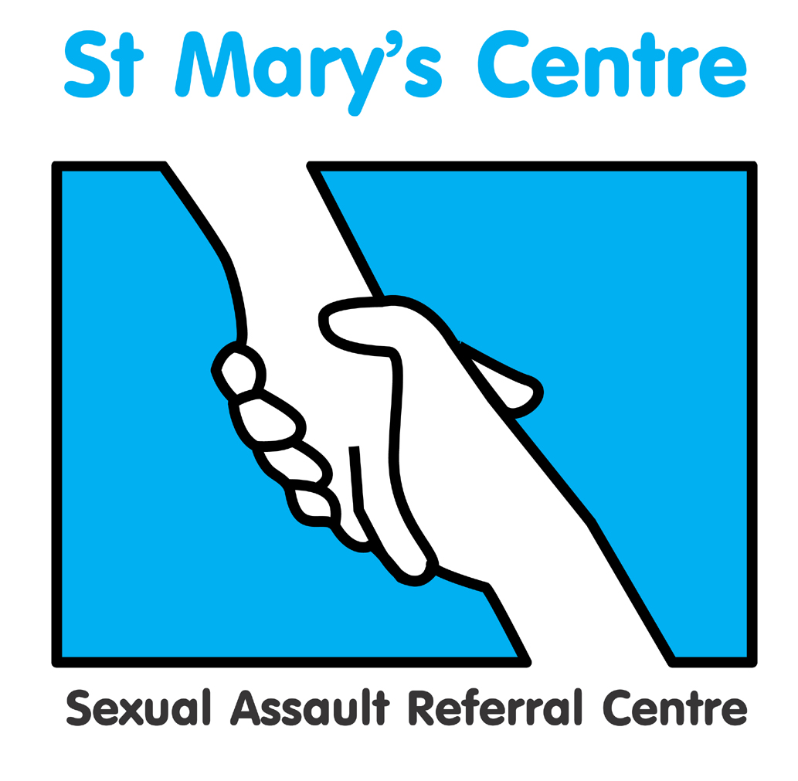

Principles of

Forensic and Medical Examination
for Rape and Sexual Assault

Course Guide for Unit One

2024 Dates:

January 23rd, 24th & 25th

March 12th, 13th & 14th

Course Lead: Dr Farah Yusuf

Contents

Section | Topic
1 | Course Lead contact Details
2 | Introduction to the Course Unit
3 | Course Unit Aims and Outcomes
4 | Teaching/Learning hours and Methods for the Course Unit
5 | Student Support During the Course Unit.
6 | Assessment
7 | Evaluation
8 | Core Learning Materials
1. Course Lead Contact Details

Name | Location | E-mail
Dr Farah Yusuf | Saint Mary’s Centre | farah.yusuf@mft.nhs.uk

2. Introduction to the Course Unit

Welcome to Unit One of the Saint Mary’s Course – Principles of Forensic and Medical Examination for Rape and Sexual Assault.

Unit 1 consists of two blocks, 3 days in January and 3 days in March. Course unit 1 is an introduction to the principles underpinning the work of the forensic clinician. The course is delivered by practitioners who are expert in their fields, and serves as the prerequisite for Unit Two, Practice of Forensic and Medical Examination for Rape and Sexual Assault.

Content of Unit 1- Block A in January

- Overview of course programme
- Essentials of genital anatomy
- Body injury classification and documentation
- Non-Fatal strangulation
- Tour of St Mary’s SARC
- Setting and Infrastructure of services
- Forensic and Medical considerations during examination
- Forensic science in relation to sexual offences
- Police Response to sexual offences
- Emergency contraception
- Post Exposure prophylaxis
- Consent and capacity
- Legal and court processes

Content of Unit 1- Block B in March

- Working through scenarios in groups
- Ethics in detail
- Child protection
- Consent for children
- Consent and capacity in adults
- Anogenital findings
- Statement writing
- Genograms
- Child sexual exploitation
- The power of listening
- domestic abuse and sexual violence
- Self-harm and the psychological effects of trauma
- Recognising and managing suicidal ideation

3. Course Unit 1 Aims and Outcomes

Aims

This course unit aims to provide qualified experienced healthcare professionals with in-depth knowledge and understanding of the theory and principles relevant to sexual offences medicine.

Outcomes

Gain Knowledge and Understanding in the following areas:

- Anatomy and physiology relevant to this field
- The nature and diversity of rape and sexual assault in the context of socio-cultural and legal definitions
- Medical and forensic management of cases of all ages
- Medico-legal and ethical considerations relevant to forensic medical examinations
- Appropriate multidisciplinary professional responses in the investigation, and prosecution of sexual violence

Intellectual Skills

  - Critically analyse literature and policy frameworks related to this field
  - Identify and critically evaluate relevant research recognising the inherent difficulties of research in this field
  - Demonstrate analytical thinking in discussion groups

Transferable Skills and Personal Qualities

- Participate in a group presentation
- Demonstrate effective written and verbal communication skills

4. Teaching/Learning Hours and Methods for the Course Unit

Unit 1 comprises of 6 full days of taught and interactive material but there will also be substantial self-directed learning outside the course. Where possible delivery of learning will be in person, but may need to be virtual dependent upon circumstances, for example virtual delivery took place during the Covid 19 pandemic.

Some 1:1 time can be arranged with tutors, if requested. Individual tutorial time may be face-to-face, virtual, telephone or email.

Independent study

There is a considerable amount of independent study which is as important to the learning as direct teaching. Some study will also be needed for the MCQ and short answer question assessments in March, which are based on the course content.

5. Student Support during the Course Unit,

Academic tutors

Each student will be allocated an academic tutor from the course teaching team. The tutor will be available for academic support and advice during the unit of study. The Course Leader is also one of the academic tutors. The best way to arrange an appointment is by contacting the tutor in person during the course or via telephone or e-mail. Please remember that all teaching team members are also engaged in many other activities and therefore may not be available at short notice. It is preferable to contact them in advance to arrange a mutually agreeable time.

- Unit 1 Assessments

Please note that assessments are undertaken with the strict understanding not to save, copy or share the questions with others.

Assessment activity | Length required | Weighting within unit
Unseen examination  Multiple choice and short answer questions paper, on key subject areas covered in Unit 1. Taken under controlled conditions. The assessment takes place during March Block B. | One hour | 50%
Case scenarios and short answer questions assignment  Students are required to complete a written task, details of which will be given in Block B. The assignment is completed after Block B concludes. |  | 50%

Attendance

The teaching day is from 9-5pm on each of the days.

Students are required to attend all taught sessions unless there are valid agreed reasons for absence. If attendance falls below 80% the missed part would need to be repeated in a future year.

Observations of forensic medical examinations

Students are encouraged to arrange shadowing of a MFFLM qualified Forensic Clinician as part of their learning, if such opportunities are available to them.

Visits

To maximise learning experience, students are encouraged to make visits to other organisations or services and share their reflections with the group. Examples include:

- a rape trial at Crown Court
- a police force’s video interview suite
- a police force’s Scenes of Crime Team
- a Sexual Assault Referral Centre other than their own
- A relevant voluntary organisation

Submission Date for Case scenarios short answer assignment

The short answer assignment will be set at the end of the March Block B. The completed assignment must be received in electronic form at St. Mary’s Centre by 12 noon on Friday 26th April 2024. Please send these to josh.edgar@mft.nhs.uk

Please provide the completed assignment in word format not PDF- this will allow the tutor to add comments when marking to help with learning. Please do not include your name on the document so it can be marked anonymously. Please submit via email.

Please note that failure to submit by the deadline will result in a mark of zero. If in exceptional cases you need an extension please contact Josh Edgar with an extension request.

Students are advised to retain a copy of written assignments and to ensure they obtain a receipt on submission.

Draft work and guidance

Academic tutors will be available to provide guidance and advice on the assignment as you are working on it. Please make contact with your tutor if advice is needed.

7. Evaluation

We greatly value your feedback on the course. The following methods of evaluation are utilised:

- Anonymous structured questionnaires (quantitative)
- Group evaluations (qualitative)
This will take place at the end of each teaching Block

Expectations – We expect students to engage with fellow students and with the course. We realise that people have different needs and learning styles and we use a wide range of teaching methods to help everyone take part. If you have particular needs and think we could help please let Josh know.

We would ask that interaction with mobile or electronic devices is minimised during taught sessions, unless it directly supports learning on the course. We do ensure frequent comfort breaks as part of the programme so taught sessions are not disrupted.

8. Core Learning Materials

Printed Resources

Clinical texts

Girardin, B.W., Faugno, D.K., Seneski, P.C., Slaughter, L., and Whelan, M. (1997) Color Atlas of Sexual Assault. St. Louis: Mosby
Miscellaneous

Heger, A. (2000) Evaluation of the Sexually Abused Child. Second Edition. Oxford: Oxford University Press.

Royal College of Paediatrics and Child Health in collaboration with Royal College of Physicians of London and its Faculty of Forensic and Legal Medicine. The Physical Signs of Child Sexual Abuse: An evidence-based review and guidance for best practice.

Stark, MM. (2020 Clinical Forensic Medicine – A Physician’s Guide. Springer Nature, SwitzerlandISBN 9783030294649

White, C. (2010) Sexual Assault, A Forensic Physician’s Practice Guide. ISBN 978-0-9564737-0-7
Best Practice and Research. Clinical Obstetrics and Gyneacology, Clinical Aspects of Sexual Violence. Vol. 27 Number 1. February 2013 (ISSN 1521-6934)

Forensic Gynaecology Series: Royal College of Obstetricians and Gynaecologists Advanced Skills Edited by Maureen Dalton 2015 (ISBN-13: 9781107064294)
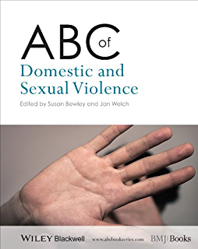

Law and Medical Ethics

Sexual Offences Act 2003. A Current Law Statute Guide Thomas JL. Sweet &
Maxwell. 2004 (ISBN 0421878304)

Mental Capacity Act Code of Practice Stationery Office. 2007 (ISBN 978 0 11
7037465)

Mental Health Act 1983 Code of Practice (2008 Edition), Stationery Office, 2008.
ISBN 978 0 11 3228096.

Mental Health Act Manual Jones, R. 11th Edition. Sweet & Maxwell. 2008 (ISBN
9781847034007)

Law and Medical Ethics 11th Edition. Mason & McCall Smith. Oxford University
Press, 2019 (ISBN 9780198826217

Principles of Biomedical Ethics.8th Edition. Beauchamp T L & Childress J F.
Oxford University Press (ISBN 13: 978-0190640873)

Key Guidance Publications

FFLM documents

www.fflm.ac.uk

GMC guidance publications

www.gmc-co.uk
Safeguarding

Royal College of Paediatrics and Child Health guidance.
available at www.rcpch.ac.uk

Working Together to Safeguard Children: A guide to inter-agency working to safeguard and promote the welfare of children.. Working Together to Safeguard Children (publishing.service.gov.uk)

RCPCH
Child protection resources – RCPCH Child Protection Portal

RCPCH Evidence & Reviews https://childprotection.rcpch.ac.uk/child-protection-evidence/

RCPCH . Child Protection Companion, Online document 2017 onwards Child Protection Companion – RCPCH Child Protection Portal (requires subscription)
Safeguarding Children and Young People: Roles and Competencies for Healthcare Staff | Royal College of Nursing (rcn.org.uk) The fourth edition of Safeguarding Children and Young People: Roles and Competences for Healthcare Staff was updated in 2019, led by the Royal College of Nursing (RCN). Updated in December 2021

Child protection service delivery standards 2020 Child protection service delivery standards – RCPCH Child Protection Portal

The Children’s Commissioner for the UK:
http://www.childrenscommissioner.gov.uk/

National Working Group on Child Sexual Exploitation
http://www.nwgnetwork.org/

Sexual Health

www.bashh.org

UK guideline for the use of HIV post‐exposure prophylaxis 2021 (bashhguidelines.org)
BASHH National Guideline on the Management of Sexually Transmitted Infections and Related Conditions in Children and Young People (2021) https://www.bashhguidelines.org/media/1294/children-and-yp-2021.pdf
The Management of Adult and Adolescent Complainants of Sexual Assault (bashhguidelines.org)
CHIVA http://www.chiva.org.uk/professionals/health/guidelines/pep/young-pep-ref.html
Post-Exposure Prophylaxis (PEP) guidelines for children and adolescents exposed to blood-borne viruses

Emergency contraception

FSRH Clinical Guideline: Emergency Contraception - Faculty of Sexual and Reproductive Healthcare

FSRH Clinical Guideline: Contraceptive Choices for Young People (March 2010, amended May 2019) - Faculty of Sexual and Reproductive Healthcare

Miscellaneous

Please feel free to access Saint Mary’s papers at the following location:
https://www.stmaryscentre.org/professionals/research/publications

Internet Resources

American Journal of Forensic Medicine and Pathology
http://www.amjforensicmedicine.com

Forensic Science International http://www.sciencedirect.com/science/journal/03790738

Journal of Clinical Forensic Medicine http://www.harcourt-international.com/journals/jcfm

Journal of Forensic Nursing http://www.forensicnurse.org

Journal of Forensic Sciences http://www.blackwell-synergy.com/loi/jfo

Journal of Legal Medicine http://www.tandf.co.uk/journals/titles/01947648.asp

Violence Against Women
http://www.sagepub.co.uk/journalsProdDesc.nav?prodId=Journal200837

Examination for the Membership of the Faculty of Forensic and Legal Medicine (MFFLM)

NSPCC learning
http://www.safenetwork.org.uk

NHS England www.england.nhs.uk

