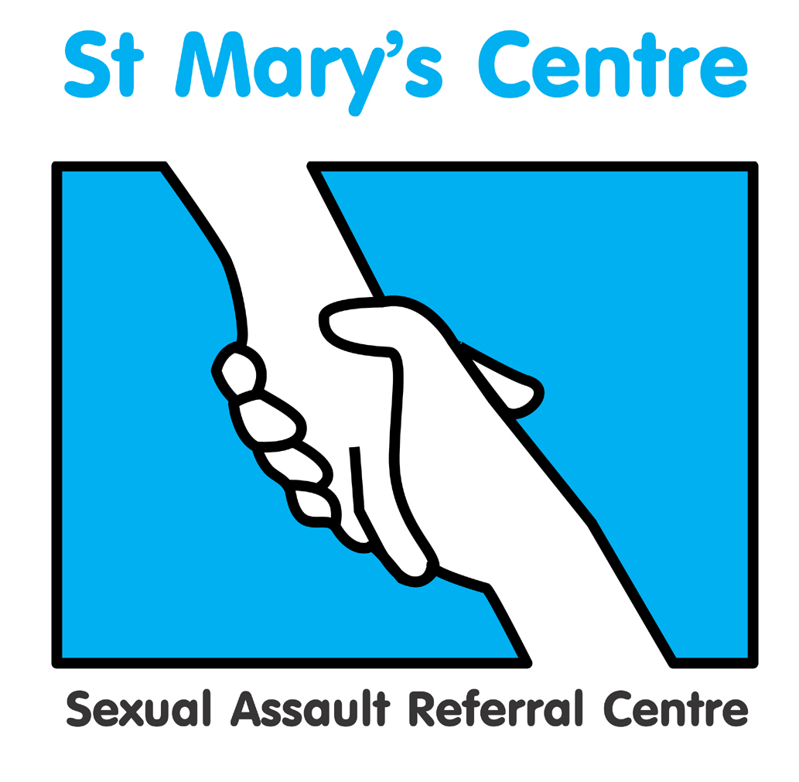

Practice of

Forensic and Medical Examination

**for Rape and Sexual Assault**

Course Guide Unit Two

## 

## 10th, 11th & 12th September 2024

## &

## 15th 16th & 17th October 2024

**Course Unit Leader: Dr Farah Yusuf**

.

Contents

|  |  |
| --- | --- |
| **Section** | **Topic** |
| 1 | Course Unit Leader Contact Details |
| 2 | Introduction to the Course Unit |
| 3 | Course Unit Aims and Outcomes |
| 4 | Teaching/Learning hours and Methods for the Course Unit |
| 5 | Student Support During the Course Unit |
| 6 | Assessment |
| 7 | Evaluation |
| 8 | Core Learning Materials |

**1. Course Unit Leader Contact Details**

|  |  |  |
| --- | --- | --- |
| **Name** | **Location** | **E-mail** |
| Dr Farah Yusuf | Saint Mary’s Centre | Farah.yusuf@mft.nhs.net |

**2. Introduction to the Course Unit**

Welcome to Unit Two of the St. Mary’s Course: *Practice of Forensic and Medical Examination for Rape and Sexual Assault*.

During this course unit you will develop further the forensic medical knowledge and skills learnt in Unit One, *Principles of Forensic and Medical Examination for Rape and Sexual Assault*, and explore further the legal framework, criminal justice process and support services underlying the work of the forensic clinician.

This course is delivered by practitioners who are experts in their fields.

Content- topics covered include:

September Block C

* Police and Criminal Evidence Act
* Examination of the suspect
* Mental Capacity Law
* Mental health assessment
* Case documentation
* Signs, symptoms and management of drug misuse
* Male rape
* Statement writing
* Crown Prosecution Service and disclosure
* Abuse of older people
* Counselling service
* Vicarious Trauma
* Role of the witness
* Child protection case studies
* Independent Sexual Violence Advisers
* Sexually Transmitted Infection screening and pathways
* Peer review
* Professional responsibilities

October Block D

* Vulnerable adults
* Learning disability
* Observation reflections
* Role of multiagency response
* Practical elements of Forensic Medical Examinations
* Child forensic Medical Examinations
* Recording examination findings
* Photo documentation of injuries
* STI screening and treatment pathways
* 1:1 Statement writing review with Crown Prosecutor
* A crown Court Judge’s view
* Court room skills day in Crown Court with King’s Counsel

**3. Course Unit Aims and Outcomes**

Aims

This course unit aims to enable qualified experienced healthcare professionals *(who have completed the course unit ‘Principles of Forensic and Medical Examination for Rape and Sexual Assault’ or are able to demonstrate equivalent knowledge and experience)* to further enhance their knowledge and understanding of legal, ethical and policy frameworks and processes relevant to the practice of forensic and medical examination for rape and sexual assault, and apply these across a range of patient groups and contexts.

Outcomes

*Knowledge and Understanding*

1. Demonstrate in-depth understanding of the Sexual Offences Act 2003 and the investigation and prosecution of rape and sexual assault.
2. Reflect on and evaluate the nature and processes for forensic examination and related forensic, medical and ethical issues.
3. Critically evaluate the evidence base in order to put any examination findings into context.
4. Demonstrate an in-depth understanding of the psychological sequelae to rape and sexual assault.
5. Demonstrate a sound understanding of factors related to the preparation of prosecution and defence cases in the context of the criminal justice process.
6. Demonstrate a clear understanding of the context of sexual violence in health presentations and the holistic needs of clients.

*Intellectual Skills*

1. Systematically identify and critically appraise, information from a variety of sources in order to develop a coherent analysis of issues relating to the practice of forensic and medical examination.
2. Utilise and apply relevant knowledge and understanding to construct sound arguments based on critical analysis and evaluation.

*Transferable Skills and Personal Qualities*

1. Prepare and write comprehensive and clear reports/statements.
2. Demonstrate effective written and verbal communication skills in a range of contexts, with other professions, the public, juries, and under cross-examination.

**4. Teaching/Learning Hours and Methods for the Course Unit**

Unit 2 comprises of 6 full days of taught and interactive material. There will also be substantial self-directed learning outside the course.

Where possible delivery of learning will be in person, but may need to be virtual dependent upon circumstances, for example virtual delivery took place during the Covid 19 pandemic.

Some 1:1 time can be arranged with tutors, if requested. Individual tutorial time may be face-to-face, virtual, telephone or email.

Independent study

There is a considerable amount of independent study which is important to learning.

A detailed case study will be delivered in the September Block. This will form the basis of a witness statement that students will write following the completion of the September Block. Students will have the opportunity to have their witness statement reviewed 1:1 with a Crown Prosecutor. The witness statement will also form the basis on which the student will have the opportunity to give oral evidence in the witness box on the court room skills day.

Self-directed study will be needed for the Essay assignment, set for after the October Block.

**5. Student Support during the Course Unit**

Academic tutors

Each student will be allocated an academic tutor from the course teaching team. The tutor will be available for academic support and advice during the unit of study. The Course Leader is also one of the academic tutors. The best way to arrange an appointment is by contacting the tutor in person during the course or via telephone or e-mail. Please remember that all teaching team members are also engaged in many other activities and therefore may not be available at short notice. It is preferable to contact them in advance to arrange a mutually agreeable time.

**6. Assessment**

|  |  |  |
| --- | --- | --- |
| Assessment activity | **Length required** | **Weighting within unit** |
| **Essay**  **Students are required to critically analyse and evaluate current research and literature relating to the significance of genital injuries in post pubertal complainants of rape and sexual assault, identifying implications for the practice of forensic and medical examination for rape and sexual assault.**  Criteria for success are:   * Ability to identify and demonstrate in-depth knowledge and understanding of relevant literature and research * Show evidence of critical analysis and evaluation of the chosen topic * Ability to integrate theory and practice. | 5,000 words (+/- 10%) | 100% |

Attendance

The teaching day is from 9-5pm on each of the days.

Students are required to attend all taught sessions unless there are valid agreed reasons for absence. If attendance falls below 80% the missed part would need to be repeated in a future year.

#### Observations of forensic medical examinations

Students are encouraged to arrange shadowing of an MFFLM qualified Forensic Clinician as part of their learning if such opportunities are available to them.

Visits

To maximise learning experience, students are encouraged to make visits to other organisations or services and share their reflections with the group. Examples include:

* a rape trial at Crown Court
* a police force’s video interview suite
* a police force’s Scenes of Crime Team
* a Sexual Assault Referral Centre other than their own
* A relevant voluntary organisation

Submission date for essay

The Essay assignment will be set at the end of the October Block D. The completed assignment must be received in electronic form at St. Mary’s Centre by **12 noon on Friday 22nd of November 2024**. Please send these to [josh.edgar@mft.nhs.uk](mailto:josh.edgar@mft.nhs.uk)

**Please provide the completed assignment in word format not PDF- this will allow the tutor to add comments when marking to help with learning. Please do not include your name on the document so it can be marked anonymously. The essay should be entirely your own work. Please submit via email.**

Please note that failure to submit by the deadline will result in a mark of zero. If in exceptional cicumstances you need an extension please contact Josh Edgar with an extension request in good time.

Students are advised to retain a copy of written assignments and to ensure they obtain a receipt on submission.

Draft work and guidance

Academic tutors will be available to provide guidance and advice on the essay as you are working on it. They will view one essay plan/outline with notes of up to 500 words providing it is received up to two weeks before the essay submission date. Tutors will not review full drafts.

1. **Evaluation**

This will take place at the end of each teaching Block. We greatly value your feedback on the course. The following methods of evaluation are utilised:

* Anonymous structured questionnaires (quantitative)
* Group evaluations (qualitative)

**Expectations** – We expect students to engage with fellow students and with the course. We understand that people have different needs and learning styles and we use a wide range of teaching methods to help everyone take part. If you have particular needs and think we could help please let Josh know.

We would ask that interaction with mobile or electronic devices is minimised during taught sessions, unless it directly supports learning on the course. We do ensure frequent comfort breaks as part of the programme so taught sessions are not disrupted.

**8. Core Learning Materials**

Audio-Visual Resources

American Forensic Nurses, **The Sexual Assault Examination: Essential Forensic Examination and Instructional Reference Guide (DVD).**

Internet Resources

#### American Journal of Forensic Medicine and Pathology

<http://www.amjforensicmedicine.com>

**British Medical Association** [www.bma.org.uk](http://www.bma.org.uk)

**Faculty of Forensic and Legal Medicine** [www.fflm.ac.uk](http://www.fflm.ac.uk)

**Forensic Science International** <http://www.sciencedirect.com/science/journal/03790738>

**General Medical Council** [www.gmc-uk](http://www.gmc-uk)

**The Home Office** [www.homeoffice.gov.uk](http://www.homeoffice.gov.uk)

**Journal of Clinical Forensic Medicine** <http://www.harcourt-international.com/journals/jcfm>

**Journal of Forensic Nursing** <http://www.forensicnurse.org>

**Journal of Forensic Sciences** <http://www.blackwell-synergy.com/loi/jfo>

**Journal of Legal Medicine** <http://www.tandf.co.uk/journals/titles/01947648.asp>

**St. Mary’s Sexual Assault Referral Centre** [www.stmaryscentre.org](http://www.stmaryscentre.org)

**The United Kingdom Assocation of Forensic Nurses**

<http://www.ukafn.org/>

**The National Society for the Prevention of Cruelty to Children**

[www.**nspcc**.org.uk](http://www.nspcc.org.uk)

**The Office of the Children’s Commissioner in England**

<http://www.childrenscommissioner.gov.uk/>