Saint Mary’s Centre 22nd Annual Conference 2025
Tuesday April 29th and Wednesday 30th 2025

The Midland Hotel, Manchester
Peter Street, Manchester, M60 2DS

Building Bridges: Collaborative Approaches to Addressing Sexual Violence

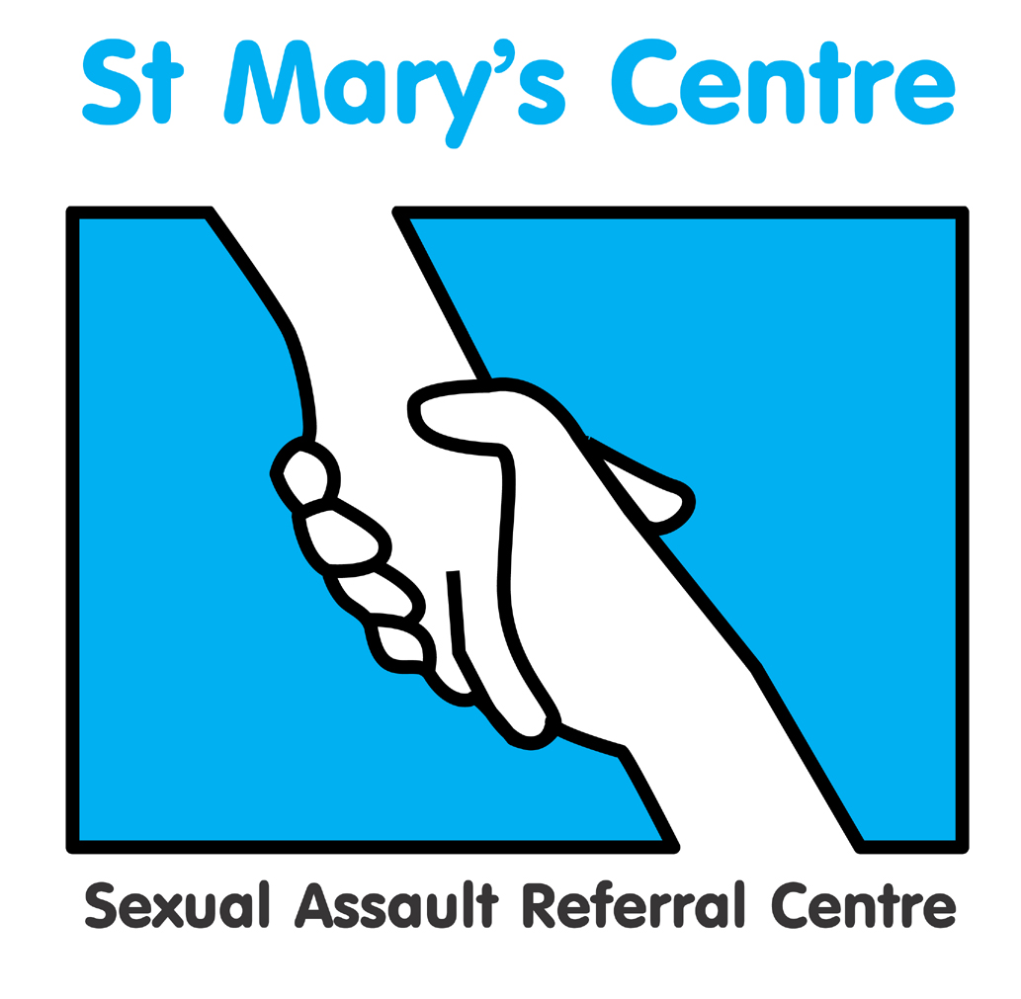

SPONSORSHIP PACKAGES

GOLD - £3000
- logo and profile in programme
- company name in footer of all email marketing of the conference
- logo on the main screen in the conference hall between sessions
- three delegate places
- exhibition stand (manned at registration, coffee breaks and lunch)
- A4 advertisement in delegate packs

SILVER - £2600
- logo and profile in programme
- logo on the main screen in the conference hall between sessions
- two delegate places
- exhibition stand (manned at registration, coffee breaks and lunch)
- A4 advertisement in the delegate packs

BRONZE - £2000
- logo and profile in programme
- A4 advertisement included in delegate packs
- one delegate place
- exhibition stand (manned at registration, coffee breaks and lunch)

If you are interested in any of these packages and wish to discuss them further,
please contact Josh Edgar, Saint Mary’s Centre, 0161 276 6515
stmarys.sarc@mft.nhs.uk

The Midland Hotel, Manchester
Peter Street, Manchester, M60 2DS

SPONSOR BOOKING F O R M
Please complete a booking form for each delegate, in BLOCK CAPITALS

Title |  | Name |  |  |  |  | Position
Organisation
Work address
Telephone |  |  |  |  |  |  | Mobile
Email
Signature |  |  |  |  |  |  | Date
Is there any way St. Mary’s Centre could support your attendance at the conference?

Any special dietary requirements, please specify

Gold Sponsor package |  |  |  | £3000
Silver Sponsor package |  |  |  | £2600
Bronze Sponsor package |  |  |  | £2000
Paying by invoice? (tick) |  |  |  | Invoice for total £ (Sterling only) to be sent to the person below
Person to be invoiced
Position
Paying organisation
Telephone
Full address
Please return the completed booking form and any purchase orders or cheques to:

Email: stmarys.sarc@mft.nhs.uk Web: www.stmaryscentre.org
- Cancellations must be received in writing before February 15th. Fees will be returned minus a 10% administration charge. No refunds will be made after that date. Programme subject to change.
Please note that bookings do not include accommodation.

