Saint Mary’s Centre 23rd Annual Conference 2026
Tuesday April 21st and Wednesday April 22nd 2026
Manchester

A Shared Vision: Reflecting on 40 Years of SARCs, Responding to Sexual Violence and Shaping the Future Together

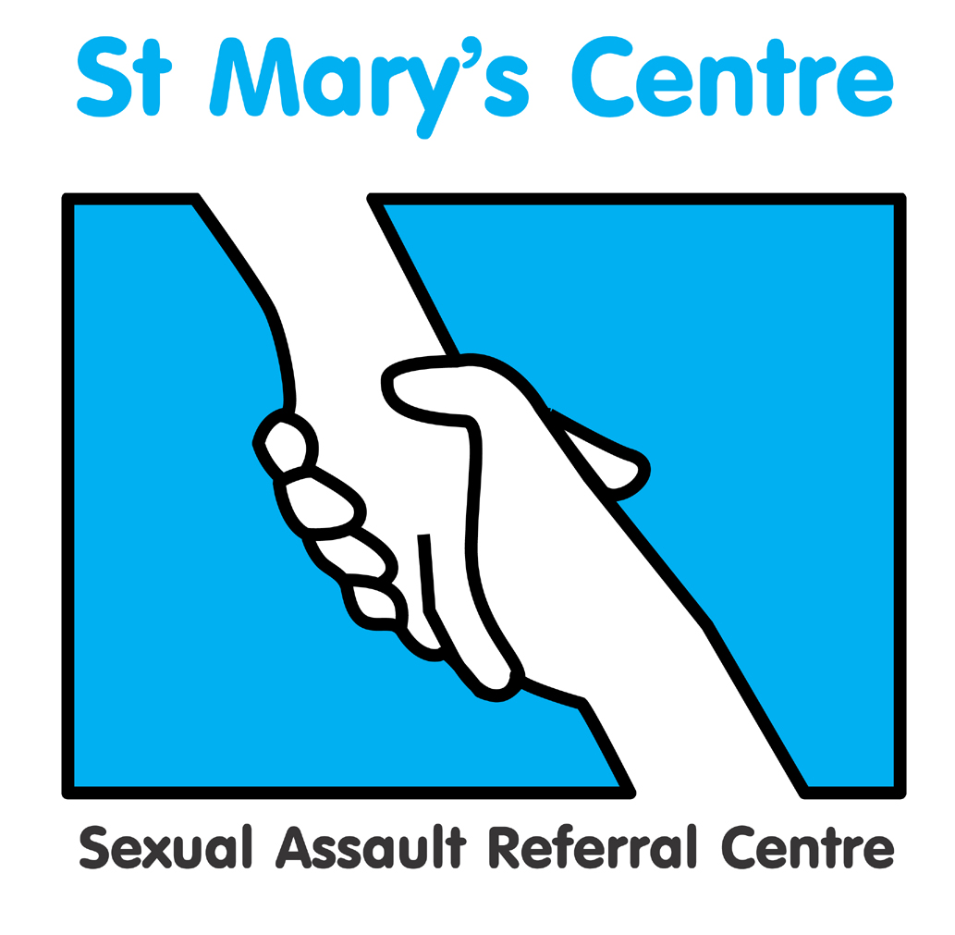

SPONSORSHIP PACKAGES

GOLD - £3000
- logo and profile in programme
- company name in footer of all email marketing of the conference
- logo on the main screen in the conference hall between sessions
- Logo and advert on screens throughout the venue
- two delegate places
- exhibition stand (manned at registration, coffee breaks and lunch)
- A4 advertisement in delegate packs

SILVER - £2600
- logo and profile in programme
- logo on the main screen in the conference hall between sessions
- two delegate places
- exhibition stand (manned at registration, coffee breaks and lunch)
- A4 advertisement in the delegate packs

BRONZE - £2000
- logo and profile in programme
- A4 advertisement included in delegate packs
- one delegate place
- exhibition stand (manned at registration, coffee breaks and lunch)

If you are interested in any of these packages and wish to discuss them further,
please contact Josh Edgar, Saint Mary’s Centre, 0161 276 6515
stmarys.sarc@mft.nhs.uk

SPONSOR BOOKING F O R M
Please complete a booking form for each delegate, in BLOCK CAPITALS

Title |  | Name |  |  |  |  | Position
Organisation
Work address
Telephone |  |  |  |  |  |  | Mobile
Email
Signature |  |  |  |  |  |  | Date
Is there any way St. Mary’s Centre could support your attendance at the conference?

Any special dietary requirements, please specify

Gold Sponsor package |  |  |  | £3000
Silver Sponsor package |  |  |  | £2600
Bronze Sponsor package |  |  |  | £2000
Paying by invoice? (tick) |  |  |  | Invoice for total £ (Sterling only) to be sent to the person below
Person to be invoiced
Position
Paying organisation
PO NUMBER
(Do not leave blank)
Telephone
Full address
Please return the completed booking form and any purchase orders or cheques to:

Email: stmarys.sarc@mft.nhs.uk Web: www.stmaryscentre.org
- Cancellations must be received in writing before February 15th. Fees will be returned minus a 10% administration charge. No refunds will be made after that date. Programme subject to change.
Please note that bookings do not include accommodation.

