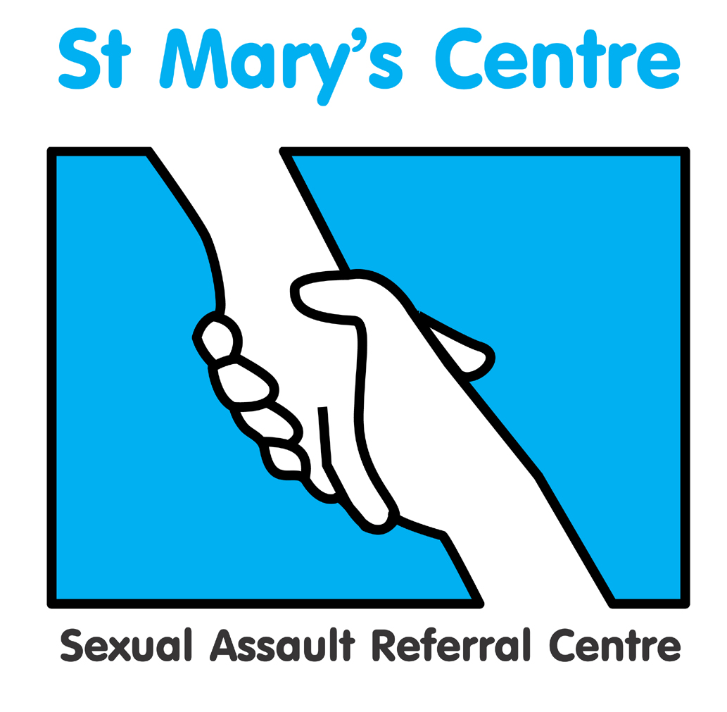

ST. MARY’S SEXUAL ASSAULT REFERRAL CENTRE

PRESENTS

SEXUAL OFFENCES MASTERCLASS

FFLM credits currently being sought.

On

Saturday November 4th 2017

At Chancellors Hotel and Conference Centre, Manchester

Booking Fee: £150.00
Book by August 12th and secure Early Bird Rate of £120.00

Enquiries:

Charlotte Batra, tel. 0161 701 2322, email:charlotte.batra@cmft.nhs.uk

St. Mary’s Sexual Assault Referral Centre
SEXUAL OFFENCES MASTERCLASS
Chancellors Hotel and Conference Centre, Manchester M14 6ZT
Saturday November 4th 2017

BOOKING FORM
Please complete a separate booking form for each individual wishing to attend

Title |  | Name |  |  |  | Position
Organisation
Work address
Postal address, if different to above
Telephone |  |  |  | Fax |  |  |  | Mobile
Email *

* Please note: your booking confirmation and programme, including venue details, will be sent by email *
Payment details |  | St Mary’s SARC will issue an invoice and payment can be made by cheque, BACs or credit card. Cheques payable to ‘CMFT’
Invoice details |  | EARLY BIRD FEE £120 AVAILABLE UNTIL AUGUST 12TH 2017  Invoice for total £ 150.00 (Sterling only) to be sent to the person below
Person to be invoiced |  |  | Position
Paying organisation/individual
Full address
Telephone
Email

How did you hear about this event?

What do you hope to achieve/obtain from attending?

Signature |  | Date
For Office Use only

Date received

Date email confirmation sent

Invoice req number

Badge

P l e a s e r e t u r n c o m p l e t e d b o o k i n g f o r m to  “Sexual offences Masterclass”, St. Mary’s Sexual Assault Referral Centre  St. Mary’s Hospital, Oxford Road, Manchester, M13 9WL  Tel: +44 (0)161 276 6515 Fax: +44 (0)161 276 6028  Email: charlotte.batra@cmft.nhs.uk Web: www.stmaryscentre.org  Cancellations must be received in writing before September 23rd 2017. Fees will be returned minus a 10% administration charge. No refunds will be made after that date. Programme subject to change |  |  |  | Clinical Director  Dr Cath White  Directorate Manager  Rachel Coppock

