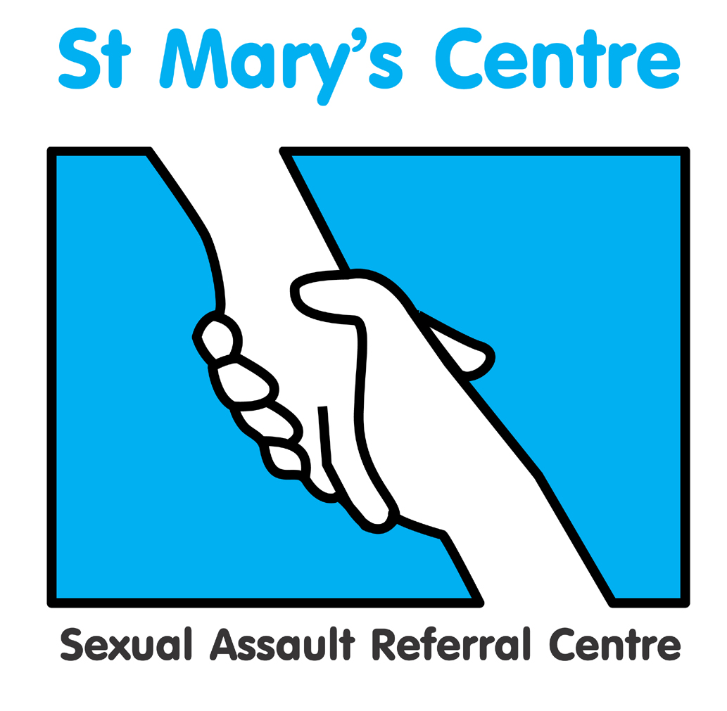 | St. Mary’s Sexual Assault Referral Centre  and The University of Manchester  Forensic and Medical Examination  for Rape & Sexual Assault Course (FMERSA) 2017
This two-module course presents Doctors and Nurses with the opportunity to train towards conducting forensic examinations of rape and sexual assault victims, under the direction of the UK’s longest established sexual assault referral centre and largest single-site university.  The course includes the medical, psychological, social and legal aspects of rape and sexual assault, focussing on the forensic examination, the collection of evidence and testimony at court. The curriculum covered will help clinicians prepare to take the membership exam for the FFLM and also the Diploma FCASA. This Dip FCASA is held by the Apothecaries. The Department of Health is aiming for all clinicians in this line of work to have at least the Dip FCASA qualification. St. Mary’s FMERSA Course covers the syllabus for this and will provide an excellent study resource.  All sessions are presented by expert practitioners in their fields, two of whom sit on the development board of Dip FCASA. Dr Cath White, the Course Director, is the Deputy Chief Examiner for the Sexual Offences aspect of the MFFLM.  Time and Place  Module One: 16-18 Jan & 13-15 March 2017  Module Two: 11-13 Sep & 9-11 Oct 2018  Each module comprises of 6 days: attendance in February AND March is required for Module One and attendance in September AND October dates is required for Module Two.  Chancellors Hotel & Conference Centre, Fallowfield, Manchester.  Module One – Principles  This module provides a comprehensive introduction to the forensic medical examination, including classifying and documenting injuries. The wider criminal justice context of police and legal processes are also explored, as well as forensic science, ethics, child protection, statement writing, and social and psychological issues.  Assessment is by a one-hour unseen examination and a 2,500 word assessed essay. A complement of visits to relevant agencies and observations of forensic examinations must also be conducted. |  | Module Two – Practice  This module provides a deeper level of detail around forensic medical and medico-legal aspects of work with rape and sexual assault. With a strong focus on the practical, the module includes paediatric examination and role of the professional witness. Further subjects include criminology, forensic odontology, effects of drugs and age, vulnerable adults, psychological effects and advanced legal issues including court role play.  Assessment is by a 5,000 word assessed essay. A complement of visits to relevant agencies and observations of forensic examinations must also be conducted.  Entry Requirements  - Registered Medical Practitioner  - Registered General Nurse at band 5 or above, or equivalent other qualified healthcare professional  - An undergraduate Diploma or equivalent from an approved University, or other approved institution of higher education (120 level 1 & 120 level 2 credits)  - Experience of practice in Women’s Health, Sexual Health, Accident and Emergency or General Practice  - Understanding of health, social and legal issues around rape and sexual assault  - Those applying for Module Two who are intending to practice as forensic examiners must have successfully completed Module One within past five years (or demonstrate equivalent skills and knowledge)  Fees  Non-residential - £1,950 per individual  module (taught sessions only). Booking both  modules reduces the fees to £3,700.  Residential - £2,200 per individual  module which includes full board during the  course of the taught sessions. Booking both  modules reduces the fees to £4,000.  Payment must be made in full before the  course commences.  Please direct all course enquiries and requests for application forms to:  Charlotte Batra  Training and Events officer  St. Mary’s Sexual Assault Referral Centre  St. Mary’s Hospital, Oxford Road  Manchester  M13 9WL  0161 701 2322  Charlotte.batra@cmft.nhs.uk  www.stmaryscentre.org  Applications for 2016 should be received no later than October 28 2017 | St. Mary’s Centre  Established in 1986, the St. Mary’s Centre was the first sexual assault referral centre in the UK and has pioneered the use of Forensic Nurse Examiners. The Centre provides forensic medical examinations, counselling and other aftercare services as well as consulting on the creation of similar services elsewhere. Serving Greater Manchester, the Centre has seen over 15,000 clients.  - www.stmaryscentre.org

Module One – Principles of Forensic and Medical Examination for Rape and Sexual Assault

The St. Mary’s SARC model | An explanation of the St. Mary’s Model for Sexual Assault Referral Centres
Injury classification and documentation | How to correctly identify and record different types of injuries
Genital anatomy | A detailed review of female and male genital anatomy
Child protection | The basic principles of child protection and common procedures for correct identification of and response to child protection issues
Pregnancy and STIs | An overview of emergency contraception, management of unwanted pregnancy, and possible sexually transmitted infections post-sexual assault
Consent and capacity | Basic concepts and ethical principles of consent and capacity as they apply to a sexual assault assessment. Exploration of difficult scenarios that may arise
Adult forensic medical examination | The method and rationale involved in the forensic medical examination of an adult victim of rape or sexual assault
Forensic Science Service | The role of the Forensic Science Service and some of the typical analyses conducted there on samples obtained by the forensic examiner
Diversity of sexual assaults | An introduction the range of sexual assaults, including different types of assault, and groups of victims, such as males, the elderly, and the very young
Social history of rape | Societal and cultural attitudes towards and perceptions of rape and sexual assault
Police investigation | How the police respond to and investigate a report of rape
Police and Criminal Evidence Act 1984 | The law covering the actions of the police and collection of evidence in criminal investigations and prosecutions
Examination of suspect | An overview of the principles involved in the examination of a rape suspect
Legal and court processes in England and Wales | How the Crown Prosecution Service prepares a case and what happens at court when a prosecution is brought, including a background history on how the current situation developed
Psychological effects | An introduction to the psychological responses to rape and sexual assault
Ethics | A basic introduction to the principles of medical ethics with an emphasis on those aspects that may apply to a sexual assault examination, including public interest and child protection
Statement writing | A guide to the production of high quality statements, common pitfalls and failings

Module Two – Practice of Forensic and Medical Examination for Rape and Sexual Assault

Differing SARC models | Different ways in which British / international SARCs operate and other venues at which forensic medical examinations may occur
Criminology | Who commits rape and why
Forensic odontology | The identification of suspects via bite marks
Recording findings | Practical aspects of note-keeping, use of proformas and body charts, and disclosure issues
Forensic laboratory visit: forensic integrity and toxicology | Maintaining forensic integrity in the examination venue and the chain of evidence. Issues surrounding analysis for alcohol and drugs
Drug awareness and DFSA | Common drugs of misuse overview, inc. alcohol, their potential effects on the examination process, managing acute withdrawal
Psychological effects | A detailed description of this form of post-traumatic stress disorder and its implications for the witness
Dermatology | Promoting an awareness of skin conditions that may mimic injuries
Genital anatomy and age | The effects of age on genital anatomy and how this may influence injury rates
Examination venues | The different locations at which the forensic medical examination may take place and the difficulties these may present
Vulnerable adults & adolescents | An awareness of the specific challenges presented by these groups
Child forensic medical examination | How the forensic medical examination should be adapted for use with children
STI screening and treatment pathways | Risk assessment and management, including post exposure prophylaxis for STIs, Hep B and HIV post-sexual assault
Forensic medical examination practice | Practical sessions in which students apply their newly taught skills on models, including use of the colposcope
Sexual Offences Act 2003 | The current law defining sexual offences in England and Wales
Mental capacity law | Legislative requirements regarding intellectually impaired examinees
CPS thematic review | Discussion regarding findings of the latest thematic review and its impact on practice
Police investigation | A detailed look at police procedures and the forensic clinician’s roles in the process
Child protection | The forensic clinician’s role and duties in child protection, looking at common scenarios
Communication | The forensic clinician must have excellent communication skills. This session looks at the development of such skills
Disclosure of notes | Discussion on the protocols and procedures for disclosure of notes
Statement writing | Interactive session working on producing statements of findings for police/court
Role of the witness | Overview of different types of witness including professional and expert with respect to their status and responsibilities
Court room skills | Role play sessions practicing giving evidence in chief and cross examination
Television documentaries | Their role in prompting developments in the treatment of victims and prosecution of sexual crimes, media perceptions
Mental health assessment | An essential guide to acute risk assessment, including suicide risk.

