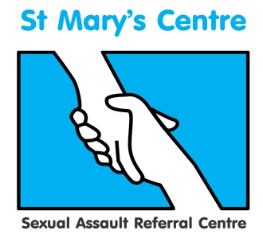

**SAVE THE DATE**

**Rape-not an isolated issue: A focus on sexual violence and multiple types of abuse**

**St Mary’s Centre 16th Annual Conference 2018**

**Wednesday April 25th and Thursday April 26th 2018**

**The Midland Hotel, Manchester**

**Who should attend?**

This conference will provide valuable insight and discussion to anyone working rape and sexual violence. In particular policy and decision makers, police officers, forensic clinicians, health professionals, those working in safeguarding, those supporting people either through the court process or therapeutically.

**Call for papers and abstracts**

Papers and posters (A1 or A0 size) are invited addressing all aspect of sexual assault for oral and poster presentations at this two-day conference. These can relate to any clinical practices or research that would be of interest to our delegates.

The conference is aimed at, among others, social care providers, police, doctors, nurses, counsellors, the legal profession, the third sector, forensic physicians and scientists.  Proposals will be reviewed and feedback provided.

Abstracts proposals should comprise: Title; aim; background; methods; results; conclusion and be no longer than 400 words.

Please submit your proposal to [charlotte.batra@cmft.nhs.uk](mailto:charlotte.batra@cmft.nhs.uk)

Deadline September 29th 2017

**St. Mary’s Sexual Assault Referral Centre was established in 1986 and our conferences have become key annual events for the discussion of new ideas and a forum for networking within the growing sexual assault aftercare community.**

**To find out more and reserve your place, please contact Charlotte Batra at**

[**Charlotte.batra@cmft.nhs.uk**](mailto:Charlotte.batra@cmft.nhs.uk) **0161 701 2322 or 0161 276 6515 /** [**www.stmaryscentre.org**](http://www.stmaryscentre.org)

**Follow us on #stmaryssarc  /St Mary’s Sexual Assault Referral Centre**