DAY ONE: Wednesday, April 25th
0830 – 0900 | Registration and refreshments
0900 – 0905 | St. Mary’s Centre  Welcome and housekeeping
0905 - 0920 | Opening Address  Mayor for Greater Manchester Andy Burnham (tbc)
Chair: Jon Rouse, Chief Officer Greater Manchester Health and Social Care Partnership
0920-0950
0950-1015 | Dr Catherine White, Clinical Director  St Mary’s SARC key project update  Interpersonal violence Centre/ACE?
1015 - 1045 | Martin Goldman – Chief Crown Prosecutor for the North West  Challenges myths and stereotypes in the courtroom
1045-1100 | Coffee
Chair: Kathy Cowell, Manchester Foundation Trust Chair
1100-1125 | Jessica Asato, Public Affairs Manager, Safer Lives  Domestic Violence and Abuse Bill – impact and opportunities
1125-12noon | Lauren Batty, Hope for Justice  Human Trafficking and Rape
1200-1225 | Jim Gamble (tbc)  On-line abuse – Everybody’s business
1225-1250 | Baroness Helen Newlove, Victim’s Commissioner  Support for survivors of rape and sexual violence
1250-1300 | Questions
1300-1400 | Lunch
Chair: Kate Davies OBE, NHS England’s Director of Health and Justice, Armed Forces and Sexual Assault Services Commissioning.
1400-1425 | Carol Seymour  President of the Faculty of Forensic and Legal Medicine  Standard setting and developing speciality for forensic medicine
1425-1455 | National evaluation of Sexual Assault Referral Centres  The effectiveness of sexual assault referral centres with regard to mental health  Professor Liz Hughes, University of Huddersfield  Honorary Professor Charlie Brooker, University of London  Multi-disciplinary evaluation sexual assault centres for better health  Dr Lorna O’Doherty, Senior Research Fellow, Coventry University (tbc)
1455-1510 | Questions
15.15-17.15 | Workshops
19.30 | Pre-Conference Drinks Reception, The Midland Hotel
20.00 | Conference dinner, The Midland Hotel

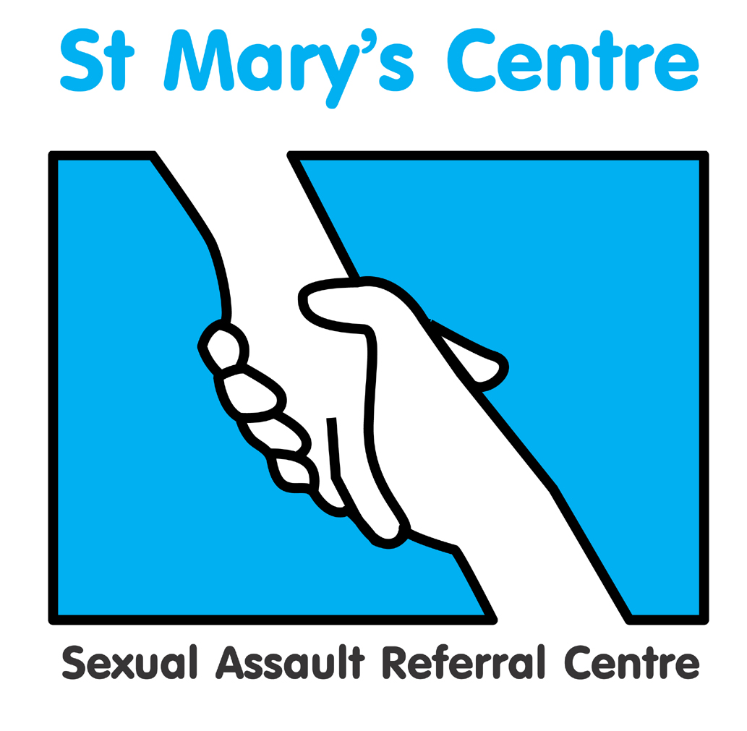
St. Mary’s Centre 16th Annual Conference 2018
Rape: Not an isolated issue:
Sexual violence and multiple types of abuse
Wednesday April 25th and Thursday April 26th,The Midland Hotel, Peter Street, Manchester M60 2DS

DAY TWO: Thursday April 26th

08.30 – 09.00 | Registration and refreshments
Chair: Honorary Recorder of Manchester, Judge Stockdale

0900-0925 | Beverley Hughes, Police and Crime Commissioner for Greater Manchester
0925-0945 | Assistant Chief Constable of Greater Manchester Police  Debbie Ford
0945-10.15 | Dame Vera Baird, Police and Crime Commissioner for Northumbria  Court mediator project
10.15-10.45 | His Honour Judge Steven Everett, Liverpool Crown Court  Section 28 – progress to date
10.45-11.00 | Questions
11.00 – 11.15 | Coffee
Chair: Chris McLoughlin, Non-Executive Director, Manchester Foundation Trust
11.15-11.40 | Professor Mark Bellis, Professor in Public Health at Bangor University and Director of Policy, Research and International Development at Public Health Wales  Adverse Childhood Experiences – Understanding and intervening in abusive lifecycles
11.40-12.45 | Latest research
11.40-11.55 | Senior lecturer Heather D Flowe, University of Birmingham, School of Psychology  Remembering rape: A randomised controlled test of the effects of acute alcohol intoxication on women’s memory for an interactive hypothetical rape scenario
11.55-12.00 | Questions
12.00- 12.15 | Dr Siobhan Weare, Lecturer in Law, Lancaster University  The experiences of men who are ‘forced to penetrate’ women. Result of the first empirical study of the subject in the UK.
12.15-12.20 | Questions
12.20-12.40
12.40-12.45 | Questions
12.45 – 13.30 | Lunch
13.30 – 15.30 | Workshops
15.30 – 16.00 | Feedback and closing remarks

Programme updated on February 14th 2018 V1

This programme is subject to change

WORKSHOPS
First hour
Event A
Title | Non-fatal strangulation project update
Content | Understanding of the impact of non-fatal strangulation in rape cases for clients and update on criminal proceedings
Speakers | St Mary’s SARC non-fatal strangulation project group led by Dr Catherine White
Chairs | Sara Wallwork, Greater Manchester Police  Jo Cunliffe, Crown Prosecution Service

Event B
Title | Understanding the extent of abuse among older people
Content
Speaker (s) | Chief Executive Action on Elder Abuse, Gary Fitzgerald
Chairs | Chris McLoughlin, Non-Executive Director, Manchester Foundation Trust

Event C – April 25th ONLY
Title | Monitoring, recording and including LGBT survivors of rape or sexual assault
Content
Speaker | Claudia Carvell, LGBT Foundation Manchester.
Chair

Event C – April 26th ONLY
Title | Bite marks and their management
Content
Speaker | Professor Geoff Craig,
Chair | St Mary’s SARC Forensic Physician

Event D
Title | Management of disclosure
Content | Why problems have arisen and what is being done to tackle the issue
Speaker | CPS/Police
Chair

Second hour
Event E
Title | Child Sexual Exploitation
Content | CSE Survivors perspective and how to encourage reporting and support
Speakers | Manchester’s Reign project and St Mary’s SARC CSE support worker, Evie McCulloch
Chair (day one) | Professor Andrew Rowland, Consultant in Paediatric Emergency Medicine
Chair (day two)

Event F
Title | Bridging the gap between domestic and sexual violence services
Content | An overview of the emerging work of the 24hour domestic and sexual violence helpline
Speakers | Sonya McMullan, Women’s Aid, Northern Ireland  Niaobh Adams, Women’s Aid, Northern Ireland
Chairs

Event G | Evidence based group therapy for rape and sexual assault clients
Title | Measuring the effectiveness of group therapy for survivors of abuse
Content
Speakers | Nicky Paris, Counselling Lead, St Mary’s Sexual Assault Referral Centre  Judith Davies, Counsellor, St Mary’s Sexual Assault Referral Centre  Roxanne Hammonds, Recovery Toolkit Manager, Rockpool  Rush Nash, Manager, Cardiff Sexual Assault Referral Centre
Chair

Event H
Title | Forensic Sampling
Content | Latest techniques and forensic sample strategies
Speaker (s) | Dr Bernadette Butler, Faculty of Forensic and Legal Medicine’s Academic Dean  Rachel Morgan, Forensic Reporting Scientist, Sexual Offences Scientific Lead, Cellmark Forensic Services
Chairs | Gillian Tully, Forensic Science Regulator  June Guiness , Forensic Science Regulator’s office
This programme is subject to change.

