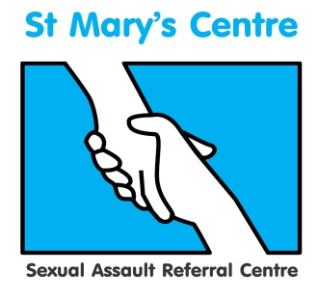

Rape-not an isolated issue: Sexual violence and multiple types of abuse

St Mary’s Centre 16th Annual Conference 2018

Wednesday April 25th and Thursday April 26th 2018

The Midland Hotel, Manchester

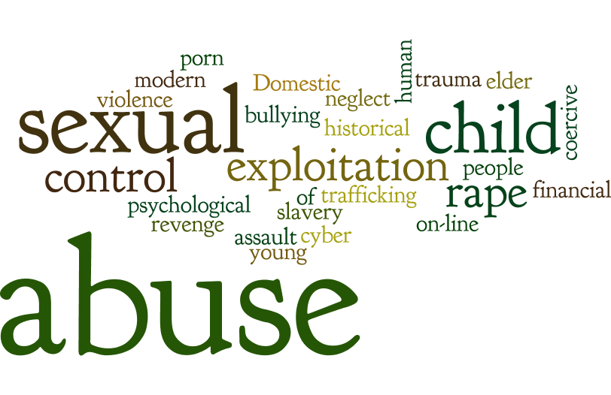
Who should attend?
This conference will provide valuable insight and discussion to anyone working rape and sexual violence. In particular:
- UK SARCs
- Health Professionals
- Forensic examiners
- Police Officers
- Paediatricians
- Social workers
- Safeguarding professionals
- Lawyers, CPS, Judges, Barristers
- Counsellors
- Sexual abuse and rape support organisations

Confirmed speakers:

Jim Gamble, Chief Executive Officer, INEQE
Baroness Helen Newlove, Victims Commissioner
Professor Mark Bellis is Honorary Professor in Public Health at Bangor University, Director of Policy, Research and Development for Public Health Wales, and Chair of the World Health Organization Collaborating Centre for Violence Prevention.
Gary Fitzgerald, CEO Action on Elder Abuse
Dame Vera Baird, Police and Crime Commissioner Northumbria
Beverley Hughes, Deputy Mayor, Greater Manchester
Carole Seymour, President of the Faculty of Forensic and Legal Medicine

St. Mary’s Sexual Assault Referral Centre was established in 1986 and our conferences have become key annual events for the discussion of new ideas and a forum for networking within the growing sexual assault aftercare community.
To find out more and reserve your place, please contact Charlotte Batra at
Charlotte.batra@mft.nhs.uk 0161 701 2322 or 0161 276 6515 / www.stmaryscentre.org
Follow us on #stmaryssarc /St Mary’s Sexual Assault Referral Centre

