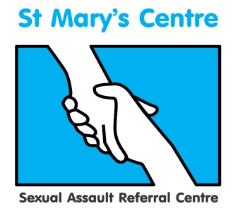

**SAVE THE DATE**

**Open about access: Making sure rape and sexual assault services are accessible to all**

**Saint Mary’s Centre 17th Annual Conference 2019**

**Tuesday April 30th and Wednesday May 1st 2019**

**Midland Hotel, Manchester**

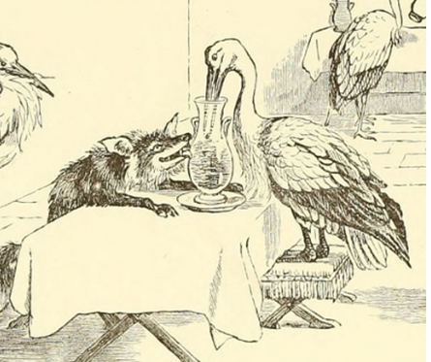

**Call for papers and abstracts**

Papers and posters (A0) size are invited addressing all aspects of sexual assault for oral and poster presentations at this two-day conference. These can relate to any clinical practices or research that would be of interest to our delegates

The conference is aimed at, among others, professionals in: social care; health care; legal and third sector.

Abstract proposals should comprise: Title; aim; background; methods; results; conclusion and be no longer than 400 words.

Paper proposals deadline is September 28th 2018.

Poster proposals deadline is February 1st 2019.

Please submit to Rachel.barber@mft.nhs.uk

**Who should attend?**

This conference will provide valuable insight and discussion for anyone working in the field of rape and sexual violence. It will be particularly useful for policy and decision makers, police officers, forensic clinicians, health professionals, those working in safeguarding, those supporting people either through the court process or therapeutically.

**Saint Mary’s Sexual Assault Referral Centre was established in 1986 and our conferences have become key annual events for the discussion of new ideas and a forum for networking within the growing sexual assault aftercare community.**

**To find out more and reserve your place, please contact Rachel Barber at**

[**Rachel.barber@mft.nhs.uk**](mailto:Rachel.barber@mft.nhs.uk) **0161 701 2322 or 0161 276 6515 /** [**www.stmaryscentre.org**](http://www.stmaryscentre.org)

**Follow us on #stmaryssarc  /St Mary’s Sexual Assault Referral Centre**