For Office Use only
Badge | Date received | Date email confirmation sent | Invoice requisition number | Reference #

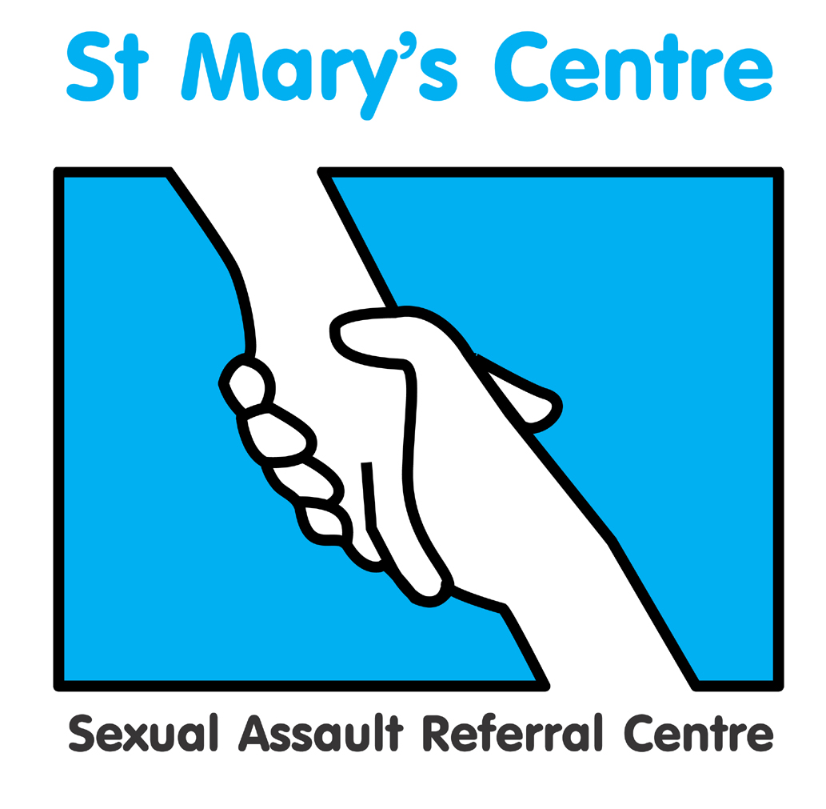

ST. MARY’S SEXUAL ASSAULT REFERRAL CENTRE

PRESENTS

SARC BEST PRACTICE DAY
&
LEVEL 3 SAFEGUARING 2019

Saturday 19th January 2019

At Chancellors Hotel and Conference Centre, Manchester

Early Bird Booking Fee: £150.00
If booked by December 3rd 2018

Standard Booking Fee: £175.00

Enquiries:

Rachel Barber, tel. 0161 276 6515, email: stmarys.sarc@mft.nhs.uk

Faculty of Forensic and Legal Medicine accreditation applied for.

Saint Mary’s SARC Best Practice & Level 3 Safeguarding Day 2019
Chancellors Hotel and Conference Centre, Manchester, M14 6ZT
Saturday January 19th 2019

B O O K I N G F O R M

Please complete a separate booking form for each individual wishing to attend this event.

Title |  | Name |  |  |  | Position
Organisation

Work address
Postal address, if different to above
Telephone |  |  |  | Fax |  |  |  | Mobile
Email address*

Please indicate any Special Dietary/Other requirements

*Please note: your booking confirmation and programme, including venue details, will be sent to you by email

PAYMENT DETAILS

Payment will be expected upon receipt of an invoice issued by St Mary’s SARC based on the information provided below.

If payment is being made by your organisation, please can you check whether you need to supply us with any additional information such as a Purchase Order numbers and if so, please include this in the space provided in the table overleaf.

Upon receipt of the invoice, you will be able to pay using a variety of methods including credit card, BACS or cheque.

Please do not include cheques when submitting this form.

Invoice details |  | Invoice for total £175.00 (Sterling only) to be sent to the person below  When booked by December 3rd 2018
Person to be invoiced |  |  | Position
Paying organisation/individual
Purchase order number

Full address invoice needs to be sent to

Telephone

Email

How did you hear about this event?

What do you hope to achieve/obtain from attending?

Signature |  | Date
P l e a s e r e t u r n c o m p l e t e d b o o k i n g f o r m to  “SARC Best Practice & Level 3 Safeguarding Day 2019”,  Saint Mary’s Sexual Assault Referral Centre  York Place, Old St. Mary’s Hospital, Oxford Road, Manchester, M13 9WL  Tel: +44 (0)161 276 6515 Fax: +44 (0)161 276 6028  Email: rachel.barber@mft.nhs.uk or stmarys.sarc@mft.nhs.uk  Web: www.stmaryscentre.org  Cancellations must be received in writing before Thursday December 20th. Fees will be returned minus a 10% administration charge. No refunds will be made after that date. Programme subject to change |  |  |  | Clinical Director  Dr Catherine White  Directorate Manager  Rachel Coppock

