Saint Mary’s Centre 18th Annual Conference 2020
Wednesday April 29th and Thursday April 30th 2020

The Midland Hotel, Manchester
Peter Street, Manchester, M60 2DS

The Science of Rape

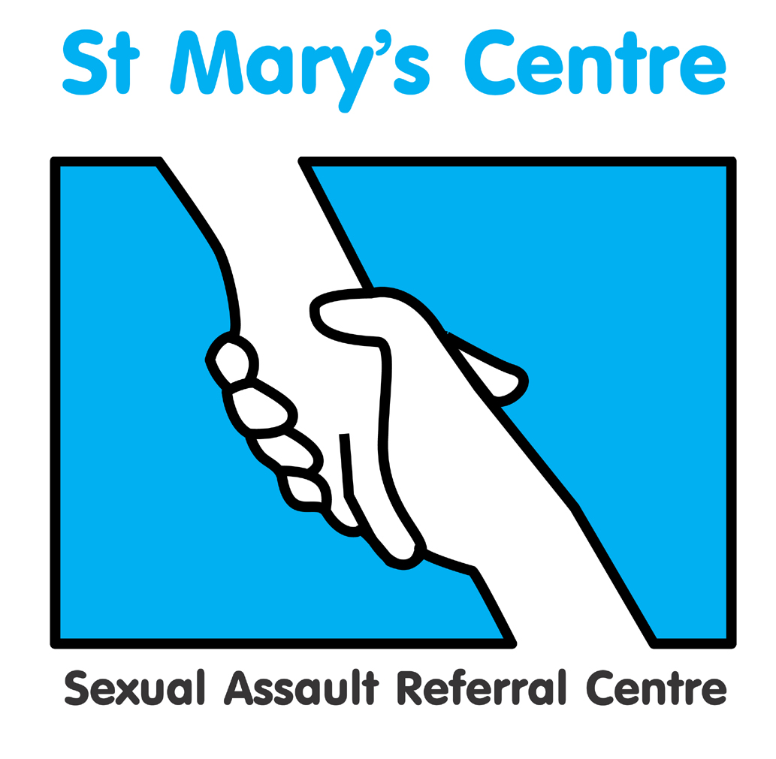

SPONSORSHIP PACKAGES

GOLD - £2000 (-100)
- logo and profile in programme
- company name in footer of all email marketing of the conference
- logo on the main screen in the conference hall between sessions
- three delegate places
- exhibition stand (manned at registration, coffee breaks and lunch)
- promotional flier in delegate packs

SILVER - £1800 (+100)
- logo and profile in programme
- logo on the main screen in the conference hall between sessions
- two delegate places
- exhibition stand (manned at registration, coffee breaks and lunch)
- promotional flier in the delegate packs

BRONZE - £1400 (+100)
- logo and profile in programme
- flier included in delegate packs
- two delegate places
- exhibition stand (manned at registration, coffee breaks and lunch)

STANDARD - £1100 (+100)
- flier included in delegate packs
- two delegate places
- exhibition stand (manned at registration, coffee breaks and lunch)

EXHIBITOR - £1000 (+100)
- exhibition stand (manned at registration, coffee breaks and lunch)
- two delegate places

CHARITIES AND THIRD SECTOR
£300
Free exhibition stand (manned at registration, coffee breaks and lunch)
- One delegate place

If you are interested in any of these packages and wish to discuss them further,
please contact Josh Edgar, Saint Mary’s Centre, 0161 276 6515
stmarys.sarc@mft.nhs.uk

Saint Mary’s Centre 18th Annual Conference 2020
Wednesday April 29th and Thursday May 30th 2020

The Midland Hotel, Manchester
Peter Street, Manchester, M60 2DS

SPONSOR BOOKING F O R M
Please complete a booking form for each delegate, in BLOCK CAPITALS

Title |  | Name |  |  |  |  |  | Position
Organisation
Work address
Telephone |  |  |  |  |  |  |  | Mobile
Email
Signature |  |  |  |  |  |  |  | Date
Is there any way St. Mary’s Centre could support your attendance at the conference?

Any special dietary requirements, please specify

Gold Sponsor package |  |  |  | £2000
Silver Sponsor package |  |  |  | £1800
Bronze Sponsor package |  |  |  | £1400
Standard package |  |  |  | £1100
Exhibitor package |  |  |  | £1000
Charity/3rd Sector |  |  |  | £300 Charity Number:
Paying by cheque? (tick) |  |  |  | Cheque for total £ (Sterling only) enclosed, made payable to MFT
Paying by invoice? (tick) |  |  |  | Invoice for total £ (Sterling only) to be sent to the person below
Person to be invoiced |  |  |  |  |  |  | Position
Paying organisation |  |  |  |  |  |  | Tel
Full address
Please return the completed booking form and any purchase orders or cheques to:

Josh Edgar, Saint Mary’s Centre, Old St. Mary’s Hospital, York Place, Off Oxford Road, Manchester, M13 9WL
Tel: +44 (0) 161 701 2322 / 276 6515 Fax: +44 (0)161 276 6028
Email: stmarys.sarc@mft.nhs.uk Web: www.stmaryscentre.org
- Cancellations must be received in writing before March 15th. Fees will be returned minus a 10% administration charge. No refunds will be made after that date. Programme subject to change.
- Please note that bookings do not include accommodation.

