For Office Use only
Reference # | Date received | Date email confirmation sent | Dinner attendance | Invoice requisition number | Badge
 |  |  | □ Yes  □ No
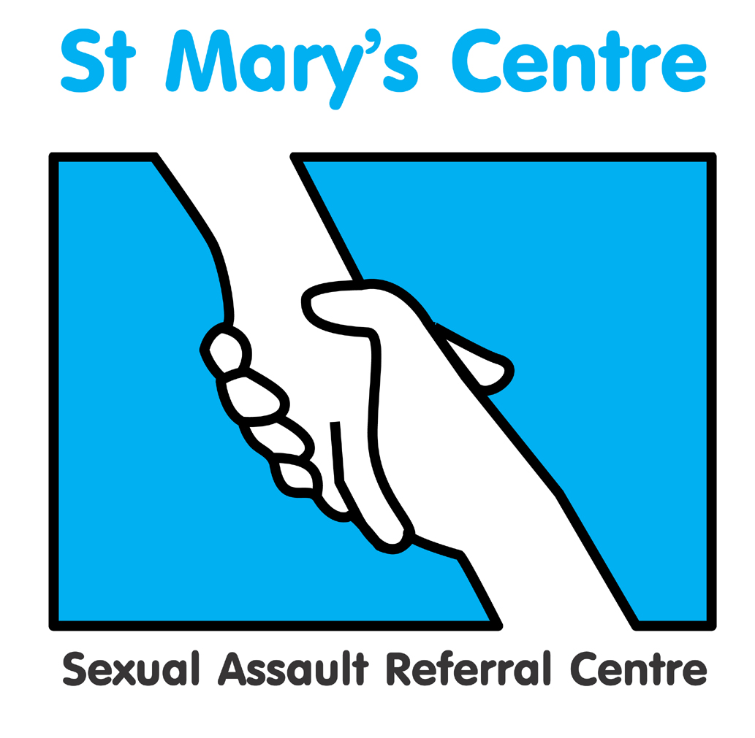

Saint Mary’s Centre 18th Annual Conference 2020
Wednesday April 29th and Thursday April 30th 2020

The Midland Hotel, Manchester
Peter Street, Manchester, M60 2DS

The Science of Rape

BOOKING FORM

PLEASE do not send payment with your booking form

Title |  | Name |  |  |  | Position
Organisation
Telephone |  |  |  | Mobile
Email

Signature |  |  |  |  |  | Date
Is there any way Saint Mary’s Centre could
support your attendance at the conference?
Please indicate any dietary requirements:

We have a number of rooms on hold at the Midland Hotel for the night of Wednesday April 30th only at The Midland Hotel, Peter Street, Manchester, M60 2DS. £149 bed and breakfast, sole occupancy. Call 0870 410 0800 and quote ‘St Mary’s Hospital 2020’ by Monday March 9th 2020 to book a room at this reduced price.

Please note the Midland Hotel is located centrally within Manchester City Centre where there are a number of hotels to choose from which are close by.
For more information on alternative hotel accommodation go to www.visitmanchester.com/stay

 | Both Days | Day One | Day Two | Early Bird Discount  Book by 31/12/19  (Two day pass)
Charities, voluntary and Third Sector |  £300 |  £180 |  £180 |  £280
UK SARCs |  £400 |  £280 |  £280 |  £300
Public Sector  (i.e. Police, Social Care) |  £420 |  £290 |  £290 |  £340
Central Government  (i.e. Dept. of Health) |  £470 |  £310 |  £310 |  £420
Private Sector |  £490 |  £330 |  £330 |  £440

Charity Commission/OSCR number (if applicable)
UK SARCs  Public Sector  Central Government  Private Sector | Group Bookings (5+ delegates booked at same time. Rate per delegate on two-day passes)  £350  £370  £420  £440
Conference evening reception/dinner  Wednesday 29th April 2020 |  | £45.00  Three course dinner at the Midland Hotel Manchester.
Please indicate any Special Dietary requirements for the evening dinner

How did you hear about this event?

What do you hope to achieve/obtain by attending?

PAYMENT DETAILS

Payment will be expected upon receipt of an invoice issued by Saint Mary’s SARC based on the information provided below.

If payment is being made by your organisation, please can you check whether you need to supply us with any additional information such as a Purchase Order numbers and if so, please include this in the space provided below.

Upon receipt of the invoice, you will be able to pay using a variety of methods including credit card, BACS or cheque.

Please do not include cheques when submitting this form.

PLEASE COMPLETE DETAILS BELOW ACCURATELY FOR INVOICING PURPOSES
Invoice details |  | Invoice for total £ (Sterling only) to be sent to the person below
Person or organisation to be invoiced |  |  | Tel
Purchase order number
(Please provide with the booking form)
Full address the invoice needs to be sent to
Email address

Please return the completed booking form and any purchase orders to:
St. Mary’s Centre, York Place (Old St. Mary’s Hospital), Off Oxford Road, Manchester, M13 9WL
Tel: +44 (0) 161 276 6515 Fax:+44 (0)161 276 6028 / stmarys.sarc@mft.nhs.uk / www.stmaryscentre.org

Cancellations must be received in writing before January 31st 2020. Fees will be returned minus a 10% administration charge. No refunds will be made after that date. Programme subject to change.

