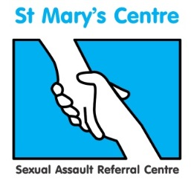

Forensic and Medical Examinations for Rape and Sexual Assault (FMERSA) 2020
Manchester

This two-module course presents doctors and nurses with the opportunity to train towards conducting forensic medical examinations of rape and sexual assault victims, under the direction of the UK’s longest established sexual assault referral centre.

The course includes the medical, psychological, social and legal aspects of rape and sexual assault, focusing on the forensic medical examination, the collection of evidence, statement writing and testimony at court. The curriculum covered will help clinicians prepare to take the Membership or the Licentiate exam of the Faculty of Forensic and Legal Medicine.

Module One – Principles

This module provides a comprehensive introduction to the forensic medical examination, including classifying and documenting injuries. The wider criminal justice context of police and legal processes are also explored, as well as forensic science, ethics, child protection, statement writing, and social and psychological issues.

Module Two – Practice

This module provides a deeper level of detail around forensic medical and medico-legal aspects of work with rape and sexual assault. With a strong focus on the practical, the module includes paediatric examination and role of the professional witness. Further subjects include criminology, forensic odontology, effects of drugs and age, vulnerable adults, psychological effects and advanced legal issues including statement writing and court role play.

Dates for 2020

Module 1 |  | Module 2
Tuesday  Wednesday  Thursday | January 14th  January 15th  January 16th | Tuesday  Wednesday  Thursday | September 8th  September 9th  September 10th
Tuesday  Wednesday  Thursday | March 10th  March 11th  March 12th | Tuesday  Wednesday  Thursday | October 13th  October 14th  October 15th

Fees
Non-residential - £1,950 per individual module. Booking both modules reduces the fees to £3,700.
Residential - £2,200 per individual module which includes full board during the course of the taught sessions. Booking both modules reduces the fees to £4,000.
For more information and to book your place on this course please contact:
stmarys.sarc@mft.nhs.uk
0161 276 6515

