For Office Use only
Date received | Date email confirmation sent | Invoice requisition number | Badge

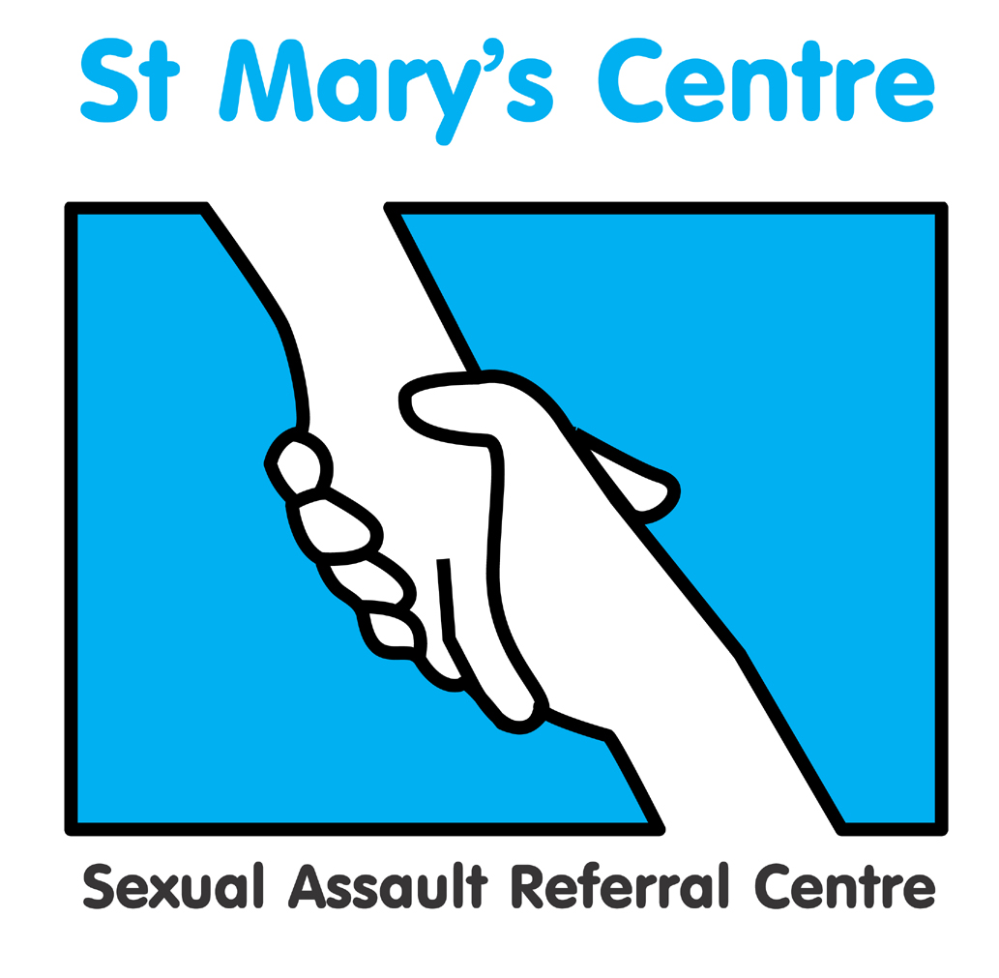

SAINT MARY’S SEXUAL ASSAULT REFERRAL CENTRE

PRESENTS

MASTERCLASS IN PAEDIATRIC ANO –GENITAL CONDITIONS
STUDY DAY

On

Thursday March 5th 2020

At University of Manchester Innovation Centre, Manchester

Faculty of Forensic and Legal Medicine and RCPCH accreditation applied for

Booking Fee: £110.00

Enquiries:

Josh Edgar, tel. 0161 701 2322, email: josh.edgar@mft.nhs.uk

Saint Mary’s Sexual Assault Referral Centre
Masterclass in Paediatric Ano-Genital Conditions Study Day
University of Manchester Innovation Centre, 48 Grafton St, Manchester M13 9XX Thursday March 5th 2020

B O O K I N G F O R M

Please complete a separate booking form for each individual wishing to attend this event.

Title |  | Name |  | Position
Organisation

Work address
Telephone

Email address*

Please indicate any Special Dietary requirements

*Please note: your booking confirmation and programme, including venue details, will be sent to you by email

PAYMENT DETAILS

Payment will be expected upon receipt of an invoice issued by Saint Mary’s SARC based on the information provided below.

If payment is being made by your organisation, please can you check whether you need to supply us with any additional information such as a Purchase Order numbers and if so, please include this in the space provided in the table overleaf.

Upon receipt of the invoice, you will be able to pay using a variety of methods including credit card, BACS or cheque.

Please do not include cheques when submitting this form.

Invoice details |  | Invoice for total £110.00 (Sterling only) to be sent to the person below
Person to be invoiced |  |  | Position
Paying organisation/individual
Purchase order number

Full address invoice needs to be sent to

Telephone

Email

How did you hear about this event?

What do you hope to achieve/obtain from attending?

Signature |  | Date
P l e a s e r e t u r n c o m p l e t e d b o o k i n g f o r m to  “Masterclass in Paediatric Conditions Study Day 2020”,  Saint Mary’s Sexual Assault Referral Centre  York Place, Old St. Mary’s Hospital, Oxford Road, Manchester, M13 9WL  Tel: +44 (0)161 276 6515 Fax: +44 (0)161 276 6028  Email: josh.edgar@mft.nhs.uk Web: www.stmaryscentre.org  Cancellations must be received in writing before Thursday January 16th. Fees will be returned minus a 10% administration charge. No refunds will be made after that date. Programme subject to change |  |  |  | Clinical Director  Dr Cath White  Directorate Manager  Rachel Coppock

