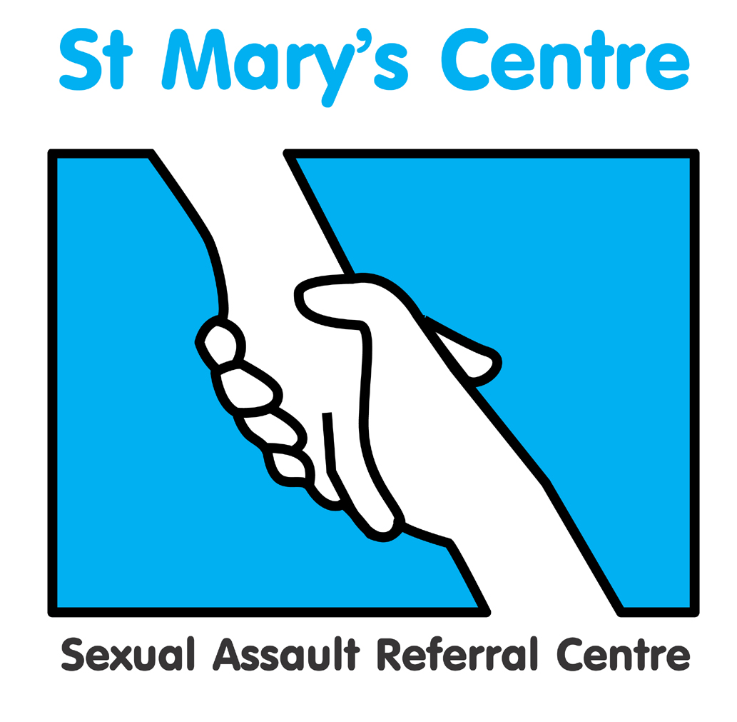

Saint Mary’s Centre 18th Annual Conference 2021
Tuesday March 16th and Wednesday March 17th 2021

Virtual Conference - Zoom

The Science of Rape

BOOKING FORM

PLEASE do not send payment with your booking form

Title |  | Name |  |  |  | Position
Organisation
Telephone |  |  |  | Mobile
Email

Signature |  |  |  |  |  | Date
Is there any way Saint Mary’s Centre could
support your attendance at the conference?

If you would like to join the SARC mailing list please write “Yes” here:

Saint Mary’s Conference would like to thank our sponsors who help in making this event possible. If you would like to be contacted by our sponsors please write “Yes” here:

 | Both Days | Day One | Day Two
Charities, voluntary and Third Sector |  £280 |  £180 |  £180
UK SARCs |  £300 |  £280 |  £280
Public Sector  (i.e. Police, Social Care) |  £340 |  £290 |  £290
Central Government  (i.e. Dept. of Health) |  £420 |  £310 |  £310
Private Sector |  £440 |  £330 |  £330

Charity Commission/OSCR number (if applicable)
UK SARCs  Public Sector  Central Government  Private Sector | Group Bookings (5+ delegates booked at same time. Rate per delegate on two-day passes)  £280  £320  £400  £420
How did you hear about this event?

What do you hope to achieve/obtain by attending?

PAYMENT DETAILS

Payment will be expected upon receipt of an invoice issued by Saint Mary’s SARC based on the information provided below.

If payment is being made by your organisation, please can you check whether you need to supply us with any additional information such as a Purchase Order numbers and if so, please include this in the space provided below.

Upon receipt of the invoice, you will be able to pay using a variety of methods including credit card, BACS or cheque.

Please do not include cheques when submitting this form.

PLEASE COMPLETE DETAILS BELOW ACCURATELY FOR INVOICING PURPOSES
Invoice details |  | Invoice for total £ (Sterling only) to be sent to the person below
Person or organisation to be invoiced |  |  | Tel
Purchase order number
(Please provide with the booking form)
Full address the invoice needs to be sent to
Email address

Please return the completed booking form and any purchase orders to:
St. Mary’s Centre, York Place (Old St. Mary’s Hospital), Off Oxford Road, Manchester, M13 9WL
Tel: +44 (0) 161 276 6515 Fax:+44 (0)161 276 6028 / stmarys.sarc@mft.nhs.uk / www.stmaryscentre.org

Cancellations must be received in writing before January 31st 2021. Fees will be returned minus a 10% administration charge. No refunds will be made after that date. Programme subject to change.

